ATTACHMENT 1 - Corridor Descriptions
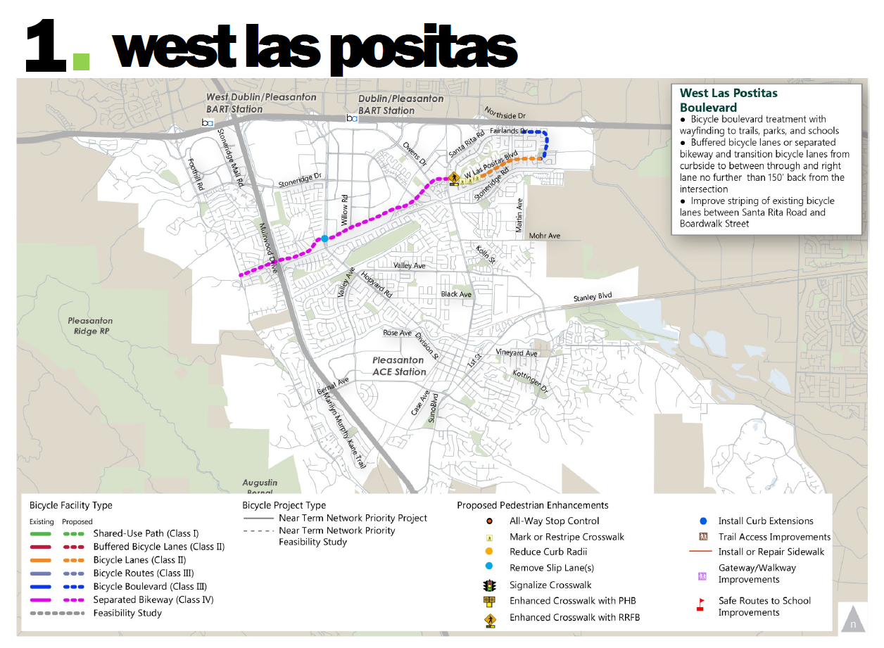
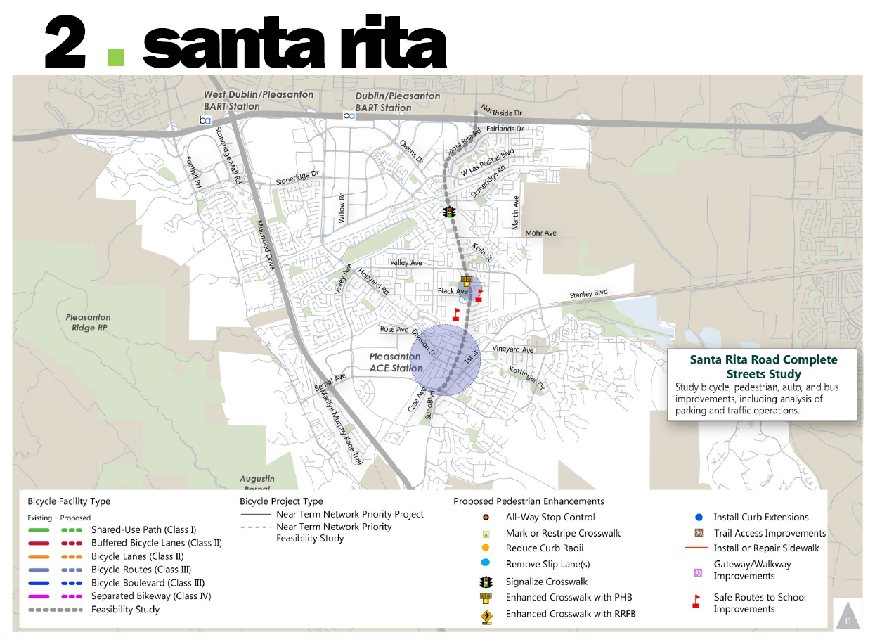
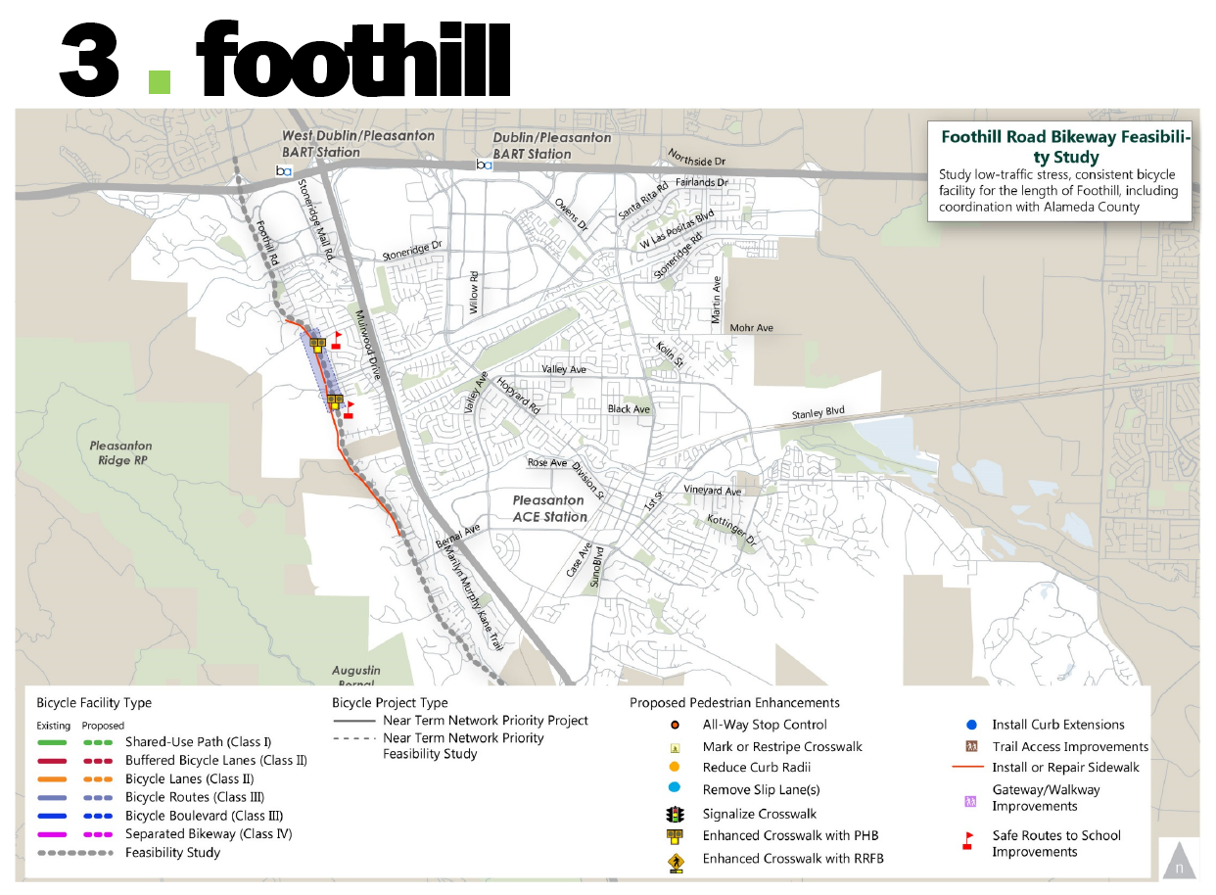
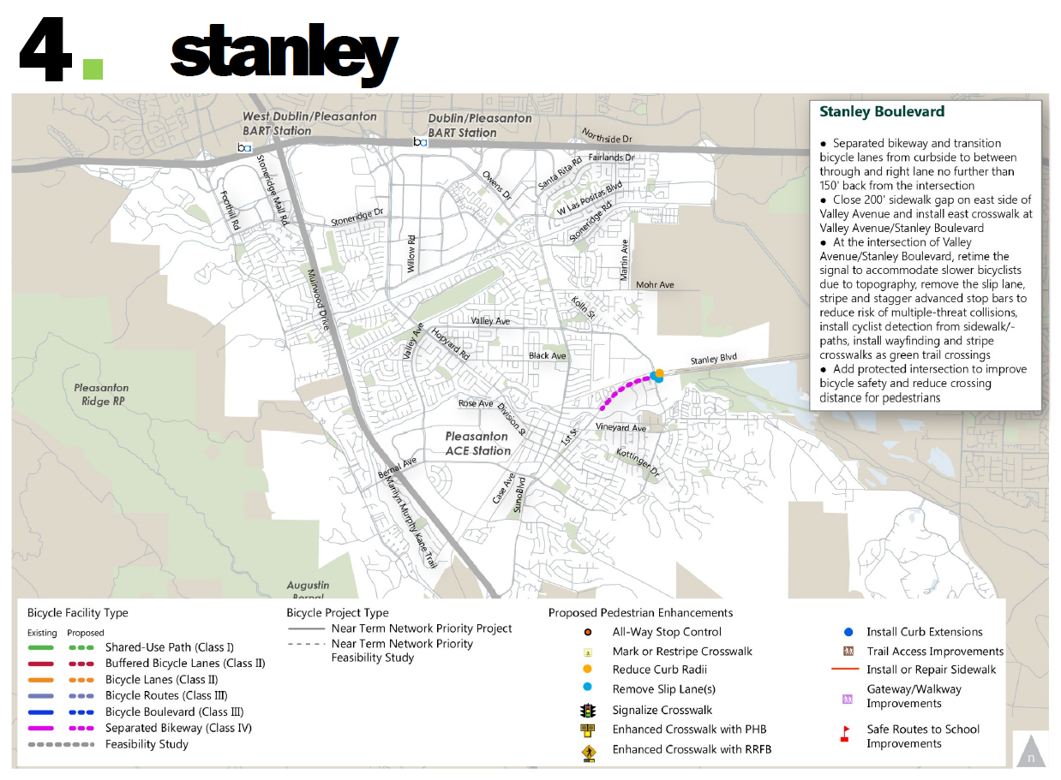
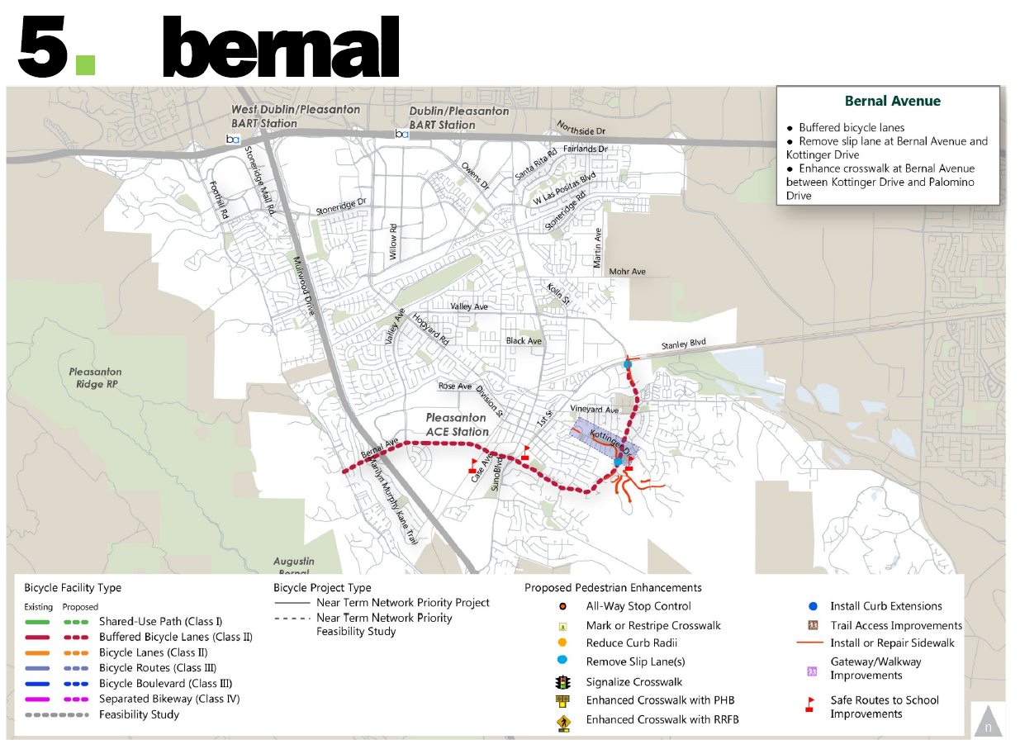
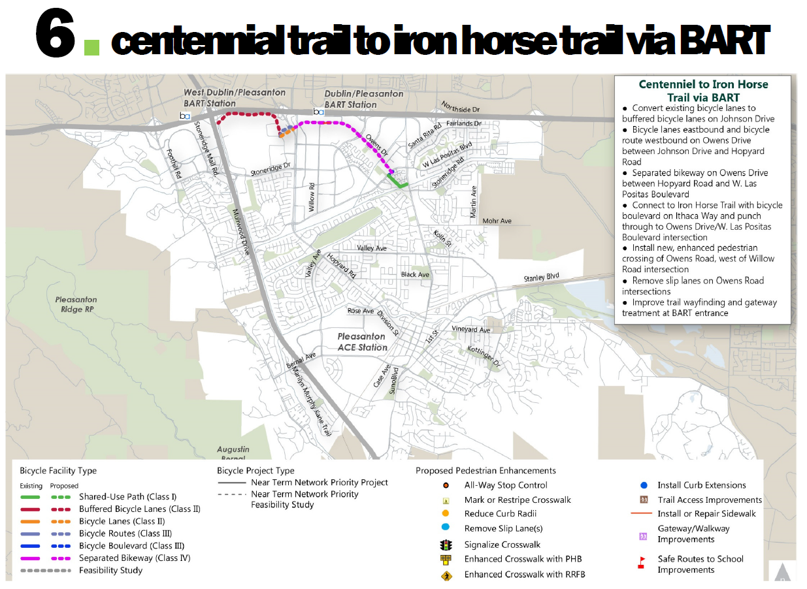
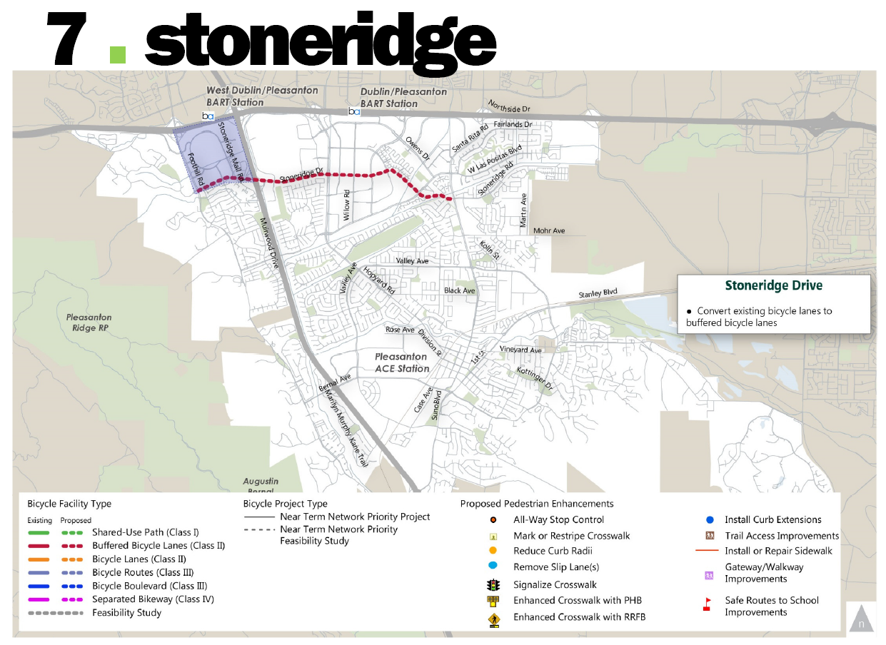
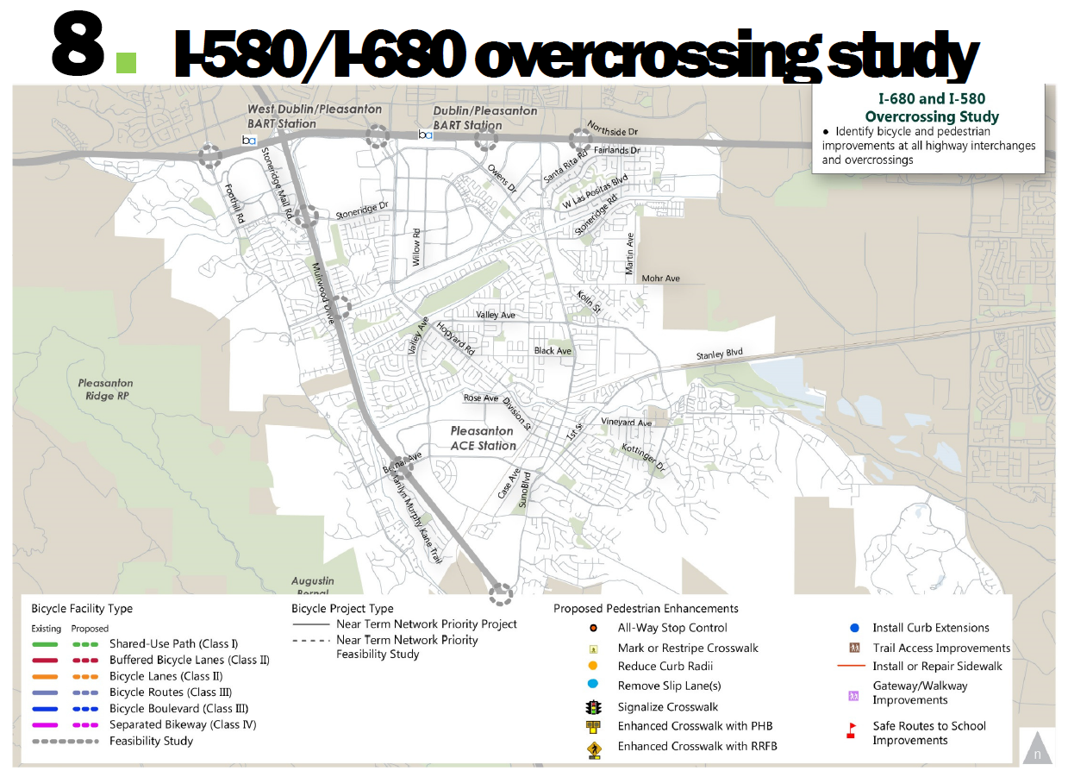
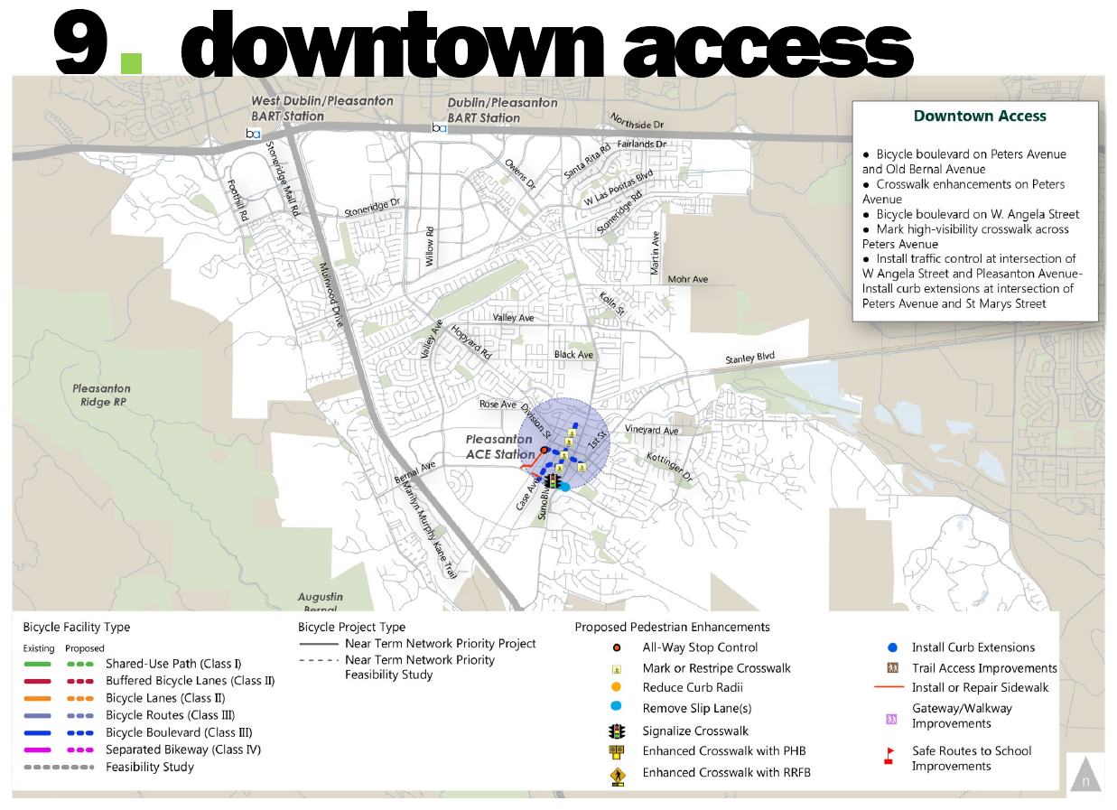
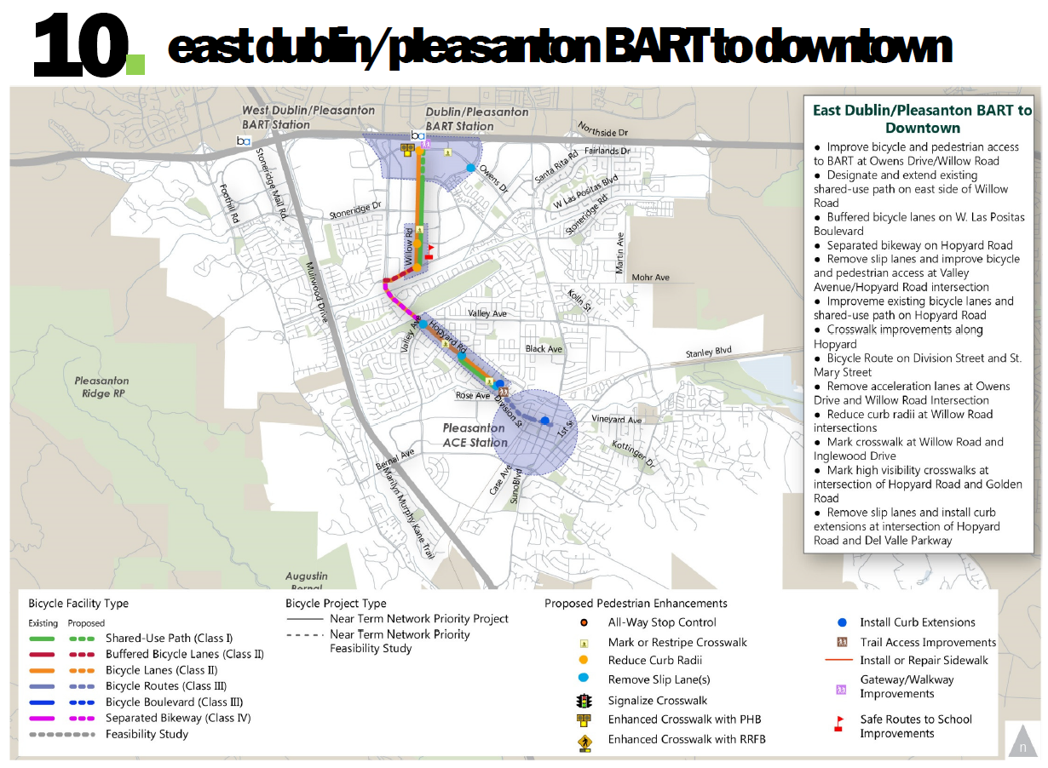
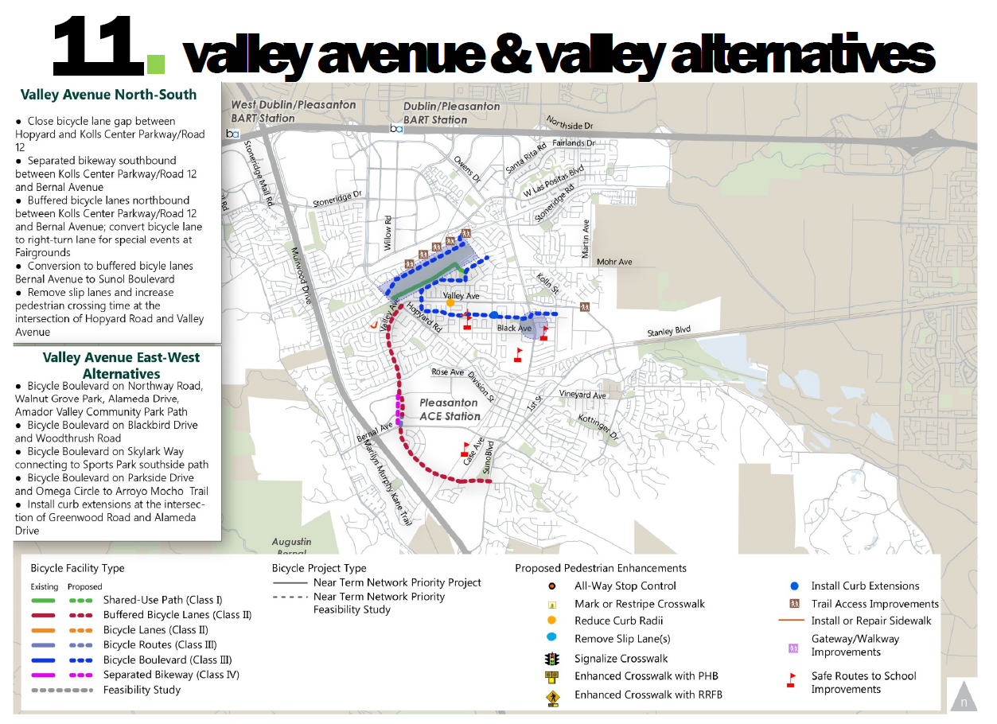
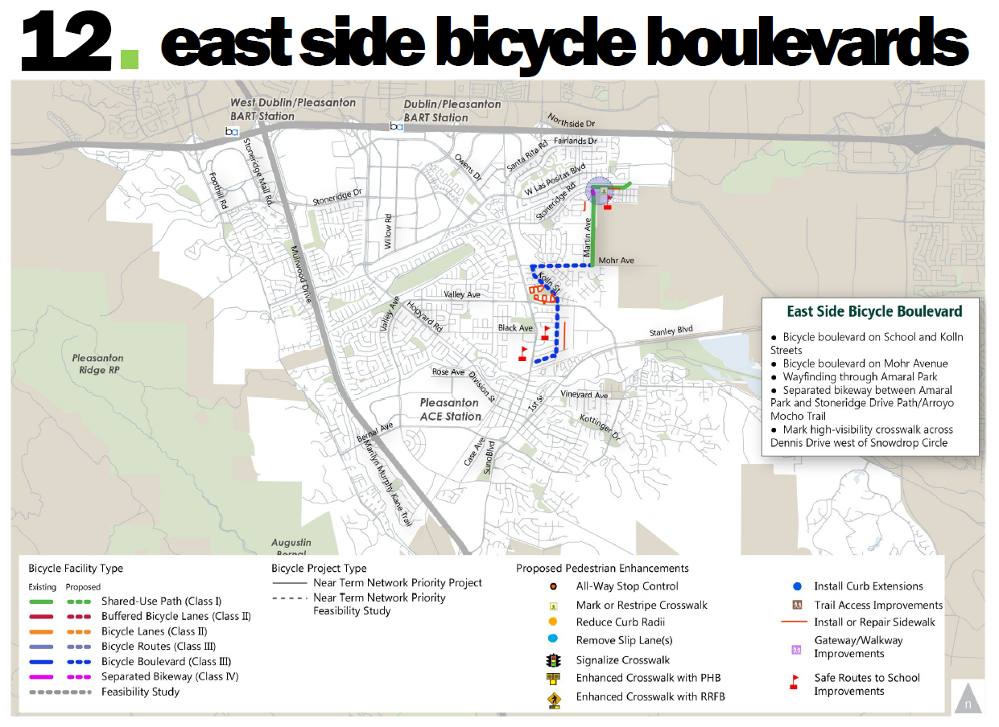
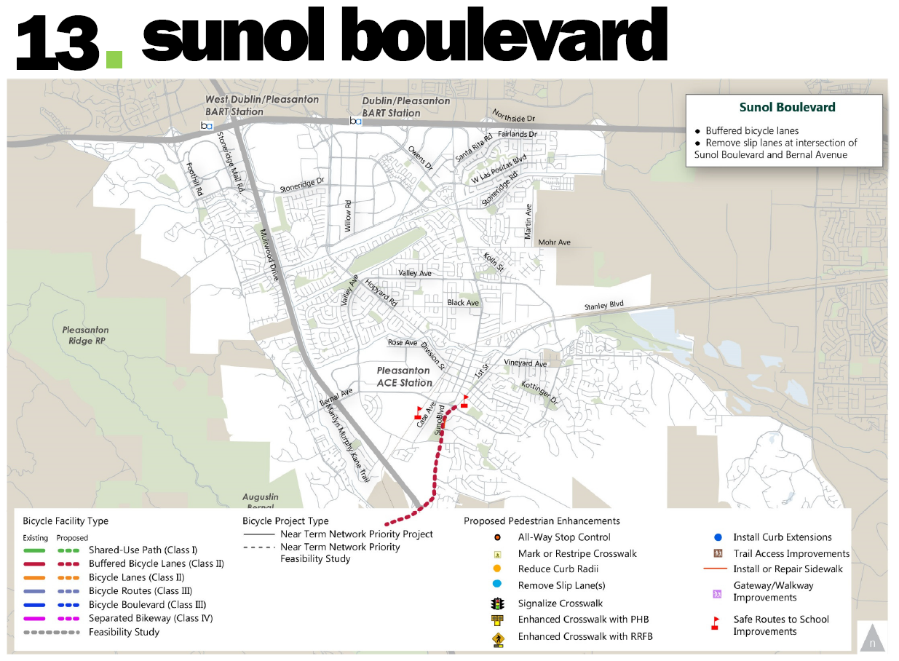
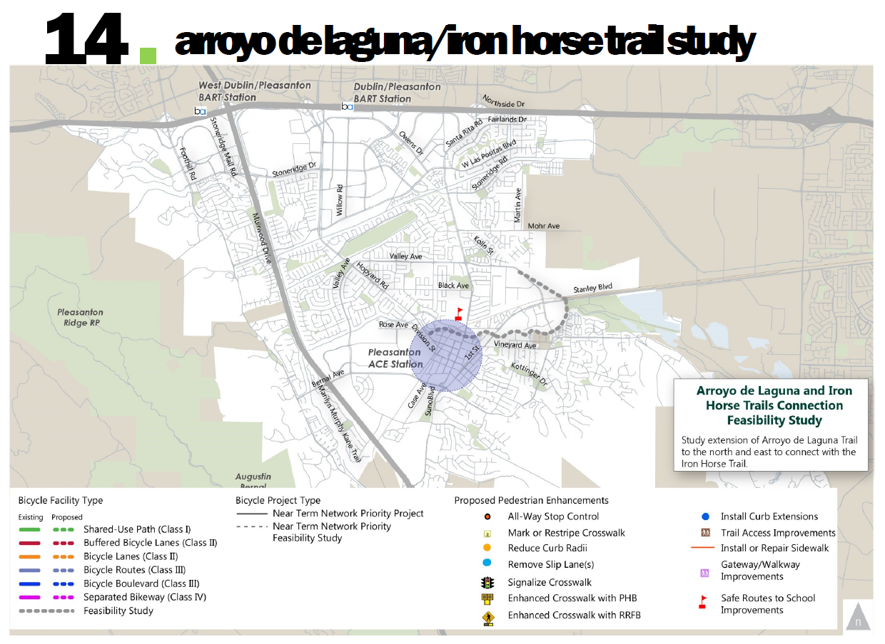
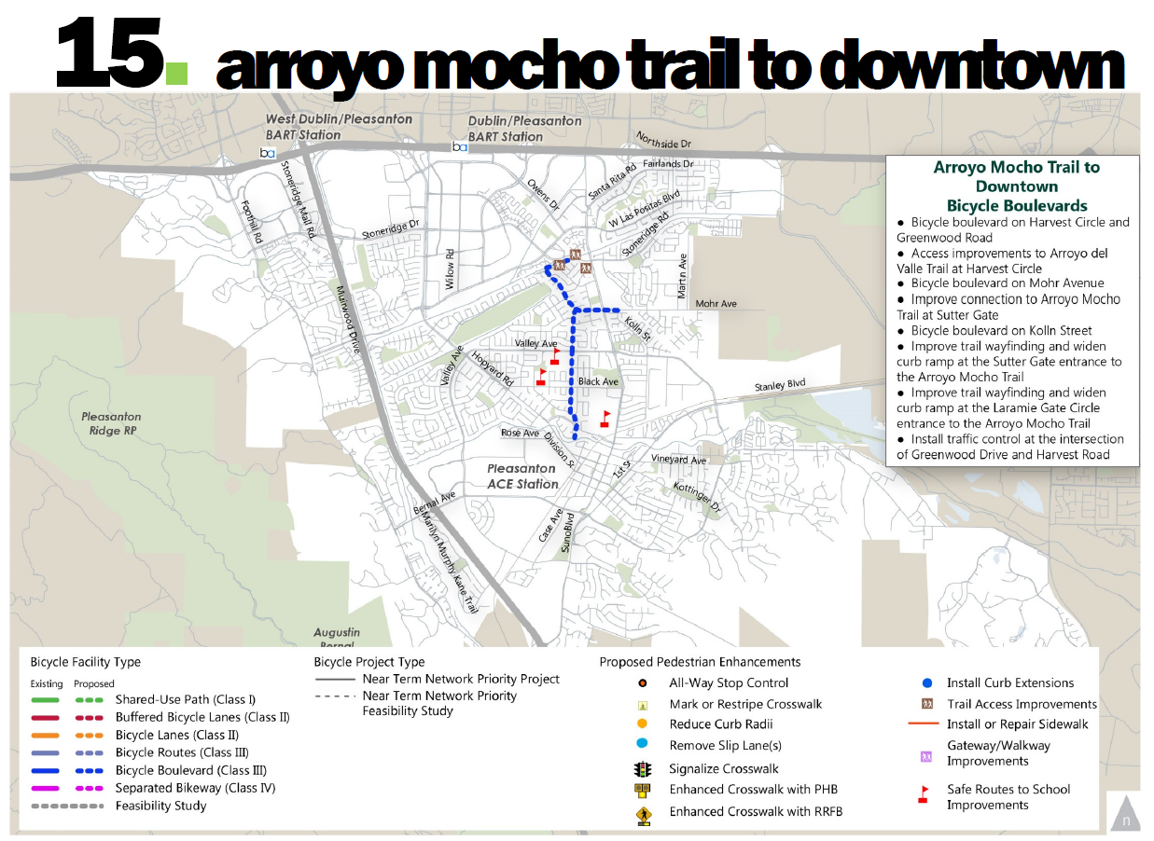
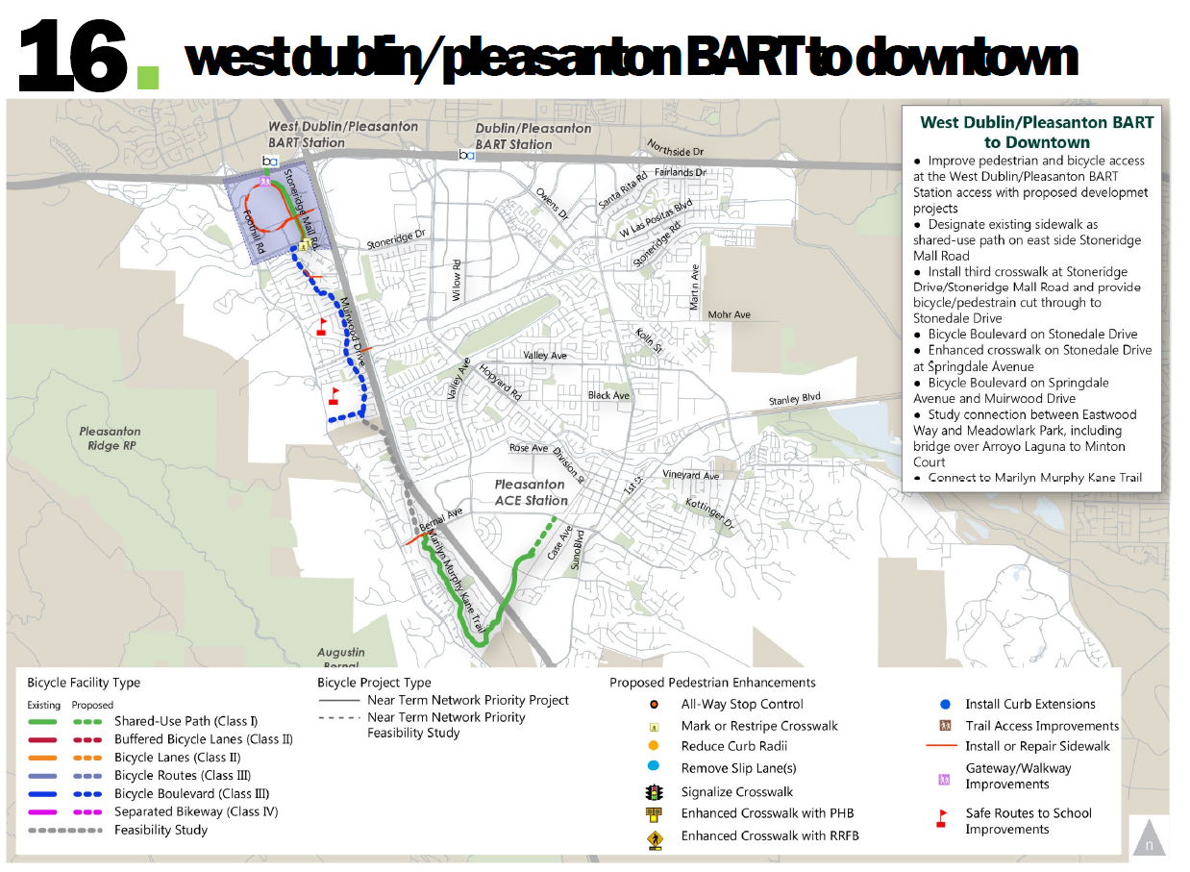

ATTACHMENT 2 - Priority Matrix

Connectivity (4 Points)
This criterion evaluates a project’s ability to create new connections or to enhance existing connections for bicyclists and pedestrians. Projects that provide a new continuous connection or complete a network gap receive the highest score. Projects that improve an existing connection help expand citywide connectivity for bikes and pedestrians receive a slightly lower score. Points are assigned as follows:

Bicycle:
4 points - Projects provide a complete low stress facility on the near-term network
3 points - Projects provide at least ½ mile of a low stress facility on the near-term network
2 points - Projects that connect or improve or create a new facility but do not provide a low-stress facility
1 point - Projects that reduce the impact of a gap but do not provide a low-stress facility

Pedestrian:
4 points - Projects that connect (i.e. provides a missing connection or closes a gap) two existing facilities within 1/8 mile of a transit station, school, trail or Downtown
3 points - Projects that connect (i.e. provides a missing connection or closes a gap) two existing facilities within 1/4mile of a transit station, school, trail or Downtown.
2 points - Projects that improve an existing connection (i.e. enhance an existing connection, as through sidewalk widening or streetscape improvements) between two existing facilities within 1/8 mile of a transit station, school, trail or within Downtown
1 point - Projects that improve an existing connection (i.e. sidewalk widening or streetscape improvements) between two existing facilities within 1/4 mile of a transit station, school, trail or within Downtown.

Walking and Biking Demand (3 Points)
This criterion evaluates the ability of a bicycle or pedestrian project to attract new walking and biking trips, particularly for existing destinations in Pleasanton, such as Downtown, the BART stations, and schools. For bicyclists, this was determined to occur with proposed facilities that feel more comfortable and accommodate a wider range of users of all ages and abilities. For pedestrians, this addresses projects within 0.5 mile of key destinations. Points are assigned as follows:

Bicycle:
3 points – Protected bikeways and protected intersections or other low traffic stress facilities that are existing well-used corridors
2 points – Buffered bike lanes or bicycle boulevards and bicycle lanes (on lower volume roadways)
1 point – Medium to high traffic stress bikeway project on a well used existing bike route.

Pedestrian:
3 points – Projects within a 1/8 mile of BART or ACE stations, Downtown, schools, or the trail network OR within a 1/4 mile of these destinations AND the project is a well-used existing walking route.
2 points – Projects within a 1/4 mile of BART or ACE stations, Downtown, schools, or the trail network OR within a 1/2 mile of these destinations AND the project is a well-used existing walking route.
1 point – Projects is a well-used existing walking route OR within a 1/2 mile of BART or ACE stations, Downtown, schools, or the trail network

Feasibility (3 points)
Projects that do not require easements, property acquisition, or additional pavement are prioritized to focus on cost-effective improvements. Political support is defined here as expressed interest by City officials and/or members of the public. Points are assigned as follows:

3 points –Projects that are feasible, have political support, are strong-contenders for grant funding; and are cost-effective.
2 points –Projects that have at least two of the following qualities: are feasible, have political support, are strong-contenders for grant funding; and are cost-effective.
1 point –Projects that have at least one of the following qualities: are feasible, have political support, are strong-contenders for grant funding; and are cost-effective.

Safety (4 Points)
This criterion is based on the number of bicycle and pedestrian collisions on the roadway over the past five years.

Pedestrian and Bicycle (on street)

4 points – Projects that improve biking or walking on the “safety priority” bicycling or walking networks AND provide or improve a bicycle or pedestrian facility at a location with at least one severe or fatal injury condition in the past 5 years.
3 points – Projects that improve biking or walking on the “safety priority” bicycling or walking networks OR has a severe or fatal injury in the past 5 years.
2 points –Projects that provide or improve a bicycle or pedestrian facility at a location with two or more bicycle or pedestrian collisions in the past 5 years.
1 point –Projects that provide or improve a bicycle or pedestrian facility at a location with one bicycle or pedestrian collision in the past 5 years.

For off-street projects, such as paths, the methodology is based on potential for conflicts with motor vehicles. Generally, paths are considered safest when they have infrequent crossings with roadways and auto traffic. However, paths with trail crossings that have the appropriate level of traffic control relative to the intersecting roadway typically offer a high degree of safety. As a result, this prioritization criterion prioritizes paths with one or more of missing or unenhanced uncontrolled trail crossings, particularly where the crossing occurs on a multi-lane roadway. This is intended to prioritize projects that install or enhance new trail crossings with the appropriate traffic control.

Pedestrian and Bicycle (off street)

3 points – Trail or paths that have one or more uncontrolled crossings or are missing crossings of arterials.
2 points – Trail or paths that have one or more uncontrolled crossings or are missing crossings of multilane collectors.
1 point – Trail or paths that have one or more uncontrolled crossings or are missing crossings of major driveways OR projects that have one or more uncontrolled crossing at local streets with limited sight distance.

Safe Routes to School (3 Points)
This criterion further prioritizes both bicycle and pedestrian projects that are common walking and biking routes to school and in close proximity to schools. In addition to the school proximity factors in other prioritization criteria, this criterion further prioritizes safety of school-aged students on those routes. Points are assigned as follows:

3 points – Projects that are within 1/8 mile of a school.
2 points – Projects that are within 1/4 mile of a school.
1 point – Projects that are within 1/2 mile of a school.

For bicyclists, 82 percent of all injury bicycle collisions occurred on one of the following nine roadways, which are therefore considered the “safety priority network” for biking in Pleasanton: Bernal Avenue, First Street, Hopyard Road, Los Positas Boulevard, Owens Drive, Santa Rita Road, Stoneridge Road, Valley Avenue, and Vineyard Avenue. For pedestrians, 74 percent of all pedestrian collisions occurred on the following 13 roadways, which are considered the “safety priority network” for walking in Pleasanton: Bernal Avenue, Chabot Drive, First Street, Gibraltar Avenue, Hacienda Drive, Hopyard Road, Las Positas Boulevard, Main Street, Owens Drive, Santa Rita Road, Stoneridge Road, Stoneridge Mall Road, and Valley Avenue.

