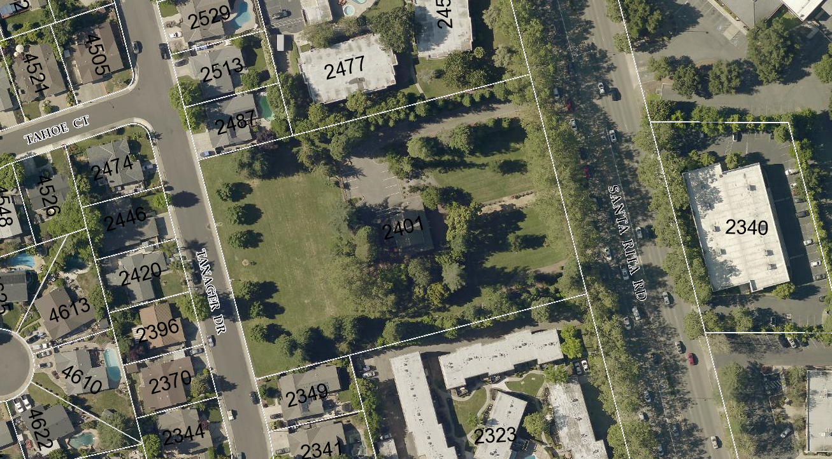
Aerial Photo ~ Century House, 2401 Santa Rita Road

