October 10, 2019
Item 8

TITLE: PARKS MAINTENANCE DIVISION QUARTERLY REPORT FOR JULY- SEPTEMBER 2019 (Q3)

SUMMARY
The Parks Maintenance Division submits a quarterly report that summarizes the recent quarter’s activities. The intent of the report is to inform the Commission of the general nature of ongoing maintenance activities for the period, project work, and other maintenance related items during the quarter.

RECOMMENDATION
That the Commission receives the report, reviews and comments.

FINANCIAL STATEMENT
None.

BACKGROUND
The Parks division has five park maintenance crews and one median, trails and open space crew. The “park” crews are comprised of four to five full-time employees that are responsible for all aspects of park maintenance in a geographic area. The “median” crew is comprised of two full-time employees with responsibilities throughout the entire city. Each crew submits quarterly reports of significant maintenance events in their respective areas. This report is a summary of those events.

DISCUSSION
Routine maintenance activities for the third quarter of 2019 included: weekly turf mowing, pesticide applications, mulch installation, tree removal, irrigation system repairs and programming, turf renovation, plant installation, leaf removal, vandalism repair, sidewalk grinding, stump grinding, equipment maintenance, sidewalk edging, ball field preparation, and weekly play area safety inspections.

Project work for the third quarter of 2019 included: Centennial trail repair, Museum on Main landscape improvements, Callippe Preserve Golf Course bunker renovations, North Valley Trails street median enhancement, Augustin Bernal fence installation, new cobblestone installation at 680/Bernal median, and concrete installation at Dolores Bengtson Aquatics Center.

The City’s tree trimming vendor, West Coast Arborist (WCA), continued with work in District 8 which includes: Bernal Avenue, First Street, Vineyard Avenue, and Valley Avenue. WCA also completed the annual Alameda County Fairground tree trimming and annual street slurry seal limb clearance trimming during this quarter.

The street median maintenance contractor, Terra Landscape, Inc., focused their main efforts on regularly scheduled spring maintenance and weed abatement.

Listed below are highlights of additional work performed by Parks staff during the third quarter of 2019:

Amador Valley Community Park
- Completed the turf renovation at Amador Park from the Shakespeare in the Park performances
- Installed new concrete at the Dolores Bengtson Aquatics Center
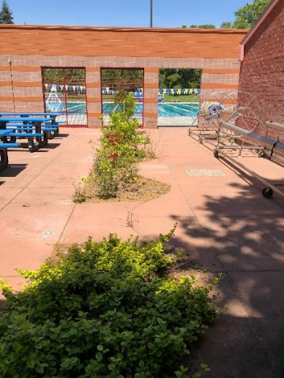
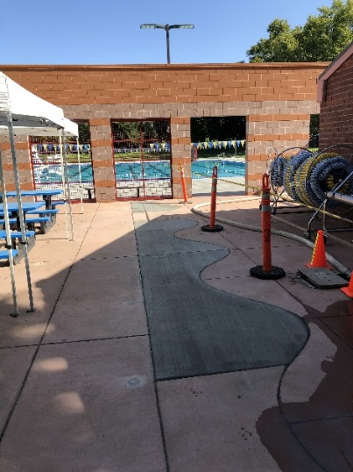

Amaral Park
- Installed three new benches
- Installed new sod near playground
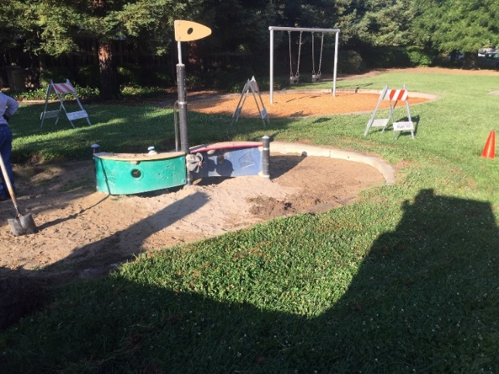
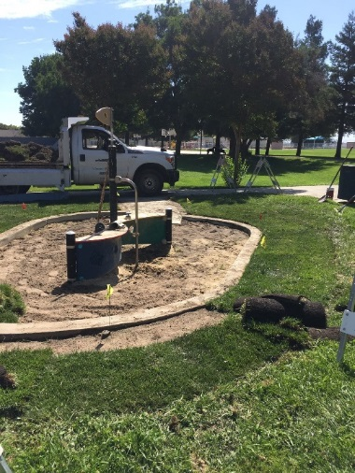

BMX Park
- Installed two new concrete picnic tables
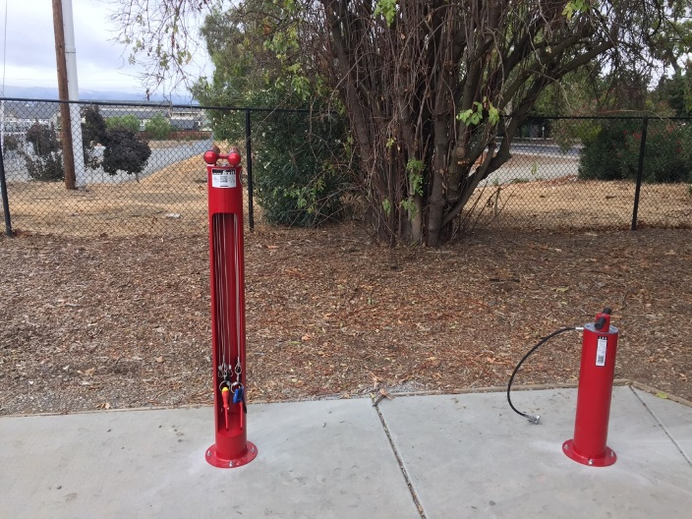
- Installed a Fix-it station

Bernal Community Park
- Cleaned up vandalism at the Playground
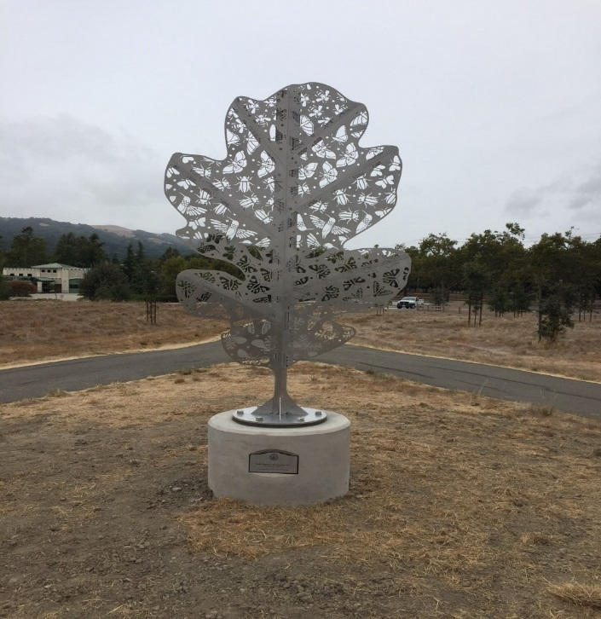
- Installed the new ‘Pollinator’ art piece in the oak woodland
Centennial Park
- Installed new concrete sidewalk along Sunol Boulevard

Creekside Park
- Installed six new concrete benches completing the picnic bench upgrade in the park
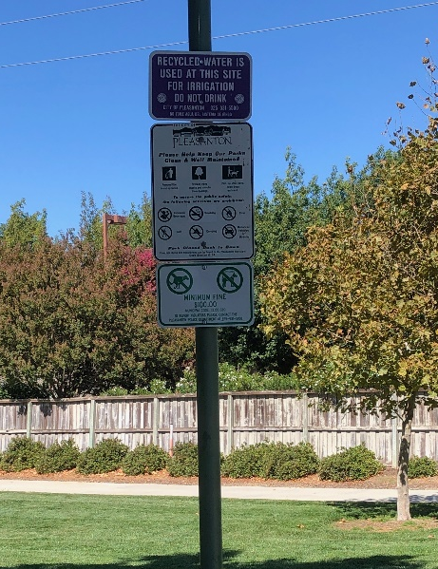
- Installed dog ordinance signage
Ken Mercer Sports Park
- Installed 1500 square feet of new sod
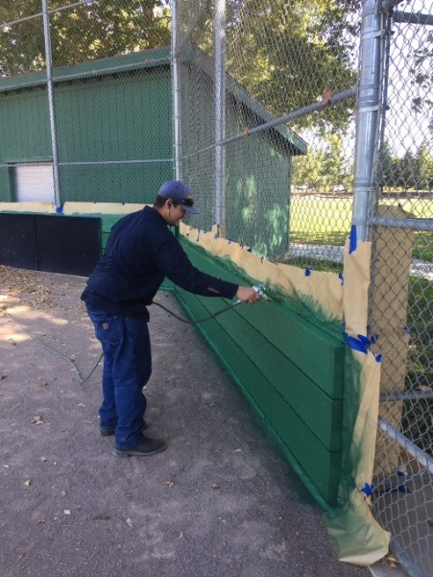
- Renovated and painted baseball and softball field dugouts

Moller Park
- Installed one owl box

Museum on Main
- Installed new landscaping in preparation for the City’s 125 year Anniversary celebration
Tennis and Community Park
- Installed new plantings near the tennis courts

Valley Trails Park
- Installed two new Calsense irrigation controllers
- Construction began on pathways leading to nearby bathroom

Val Vista Community Park
- Installed new wind socks
- Removed a damaged slide at large playground
- Removed 12 diseased pear trees
- Repaired vandalized chain link gate and fencing
- Prepared Val Vista Community Park soccer fields for the RAGE College Showcase
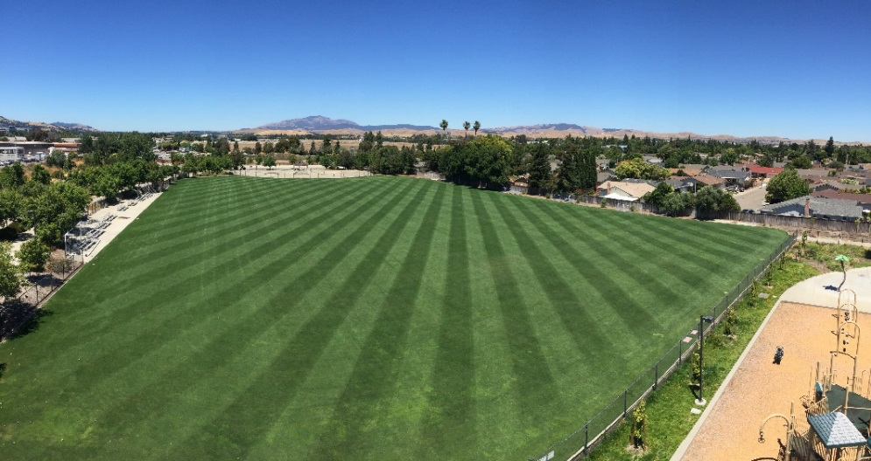

- Installed two owl boxes

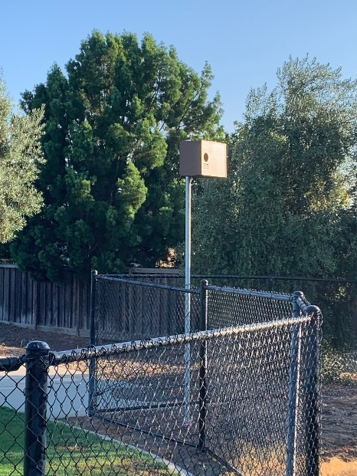
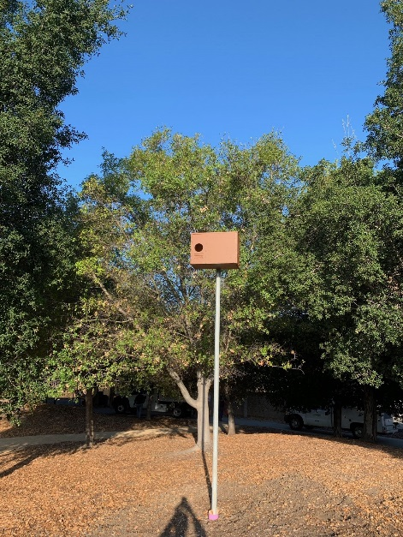

Additional Parks Division Areas of Responsibilities:

Trails, Callippe Preserve Golf Course, Medians and Urban Forest

Augustin Bernal Trail
- Installed fencing along the new parking lot
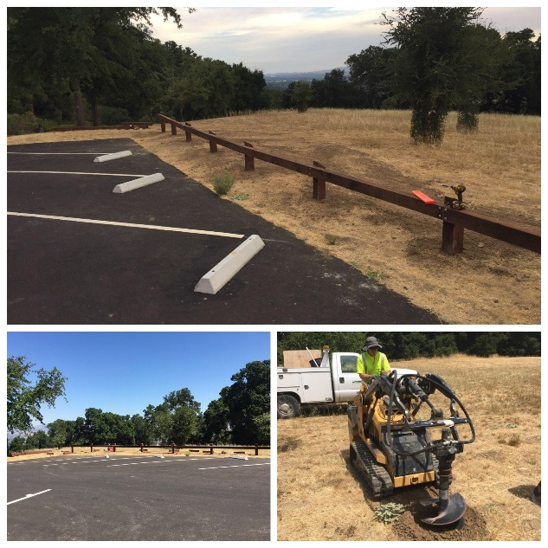

Centennial Trail
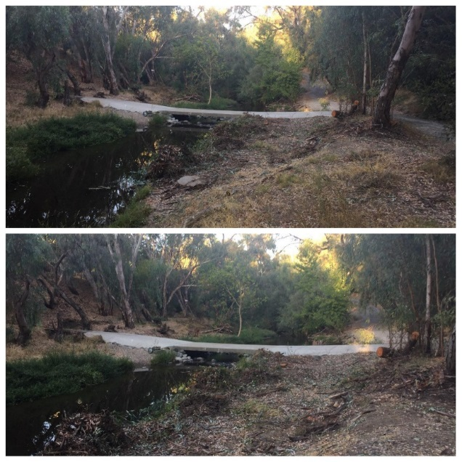
- Repaired and re-opened the storm damaged section of the trail
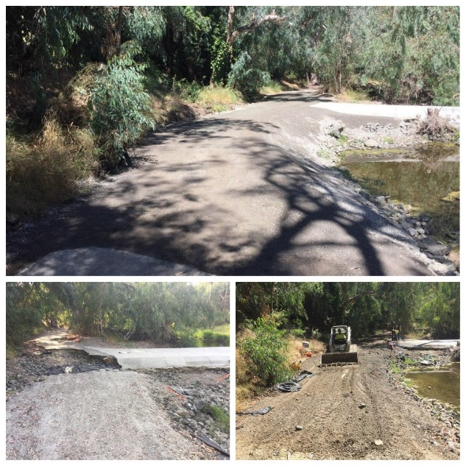

Callippe Preserve Golf Course
- Renovated greenside bunkers on hole: #2, #5, and #8

Hole #2 Before and After

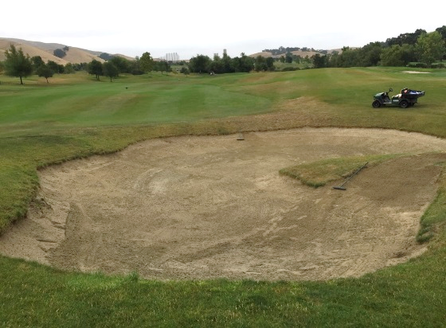
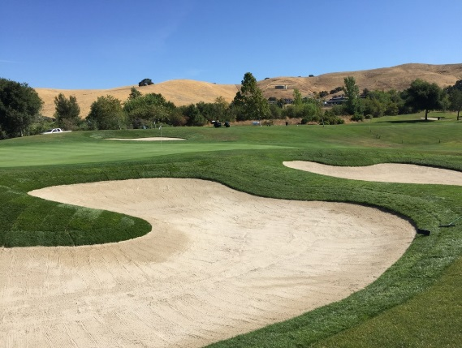
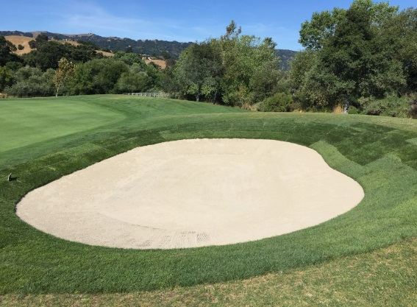
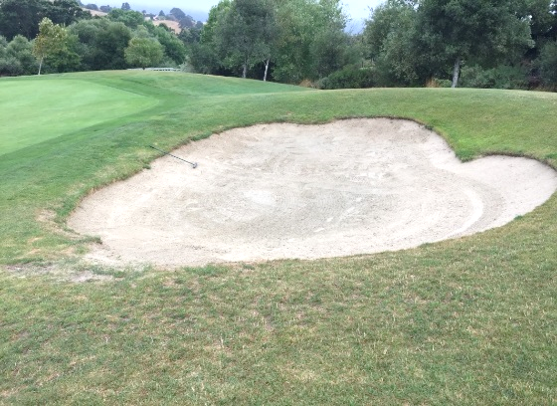
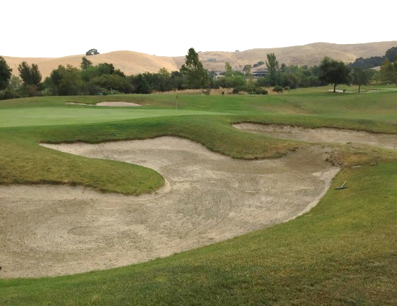

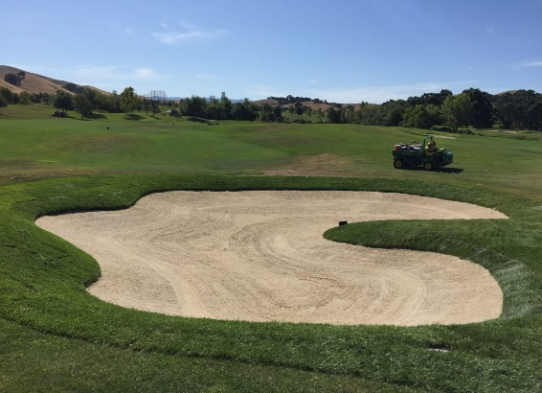

Hole #5 Before and After
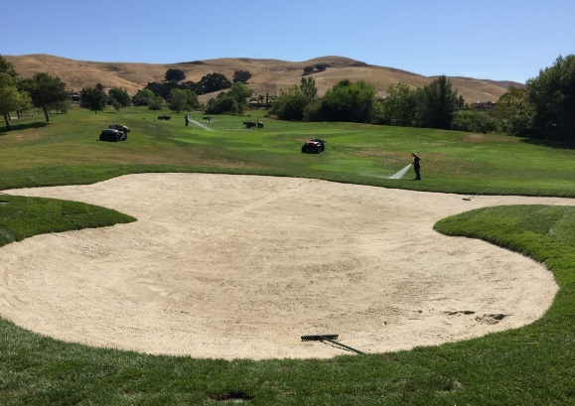
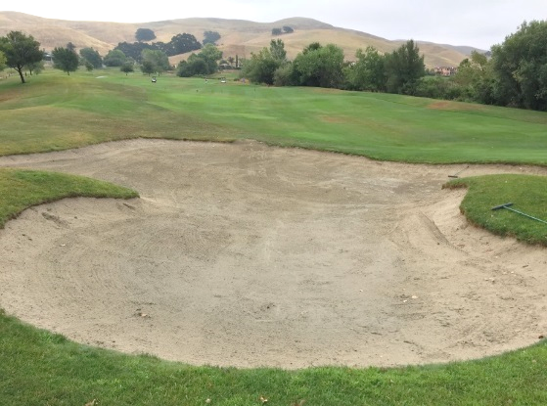

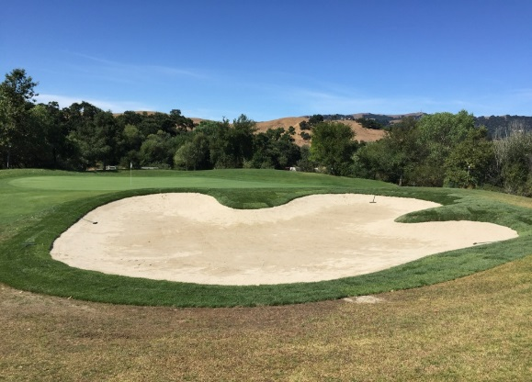
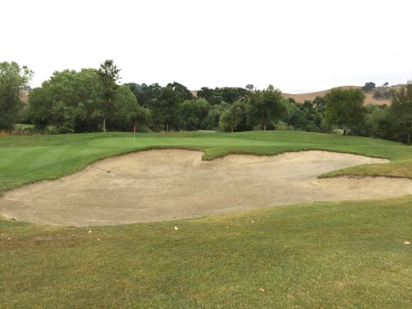

Hole #8 Before and After

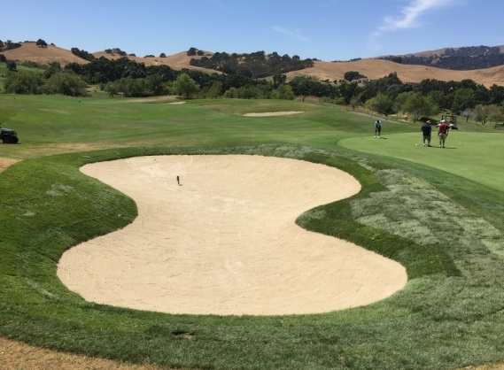
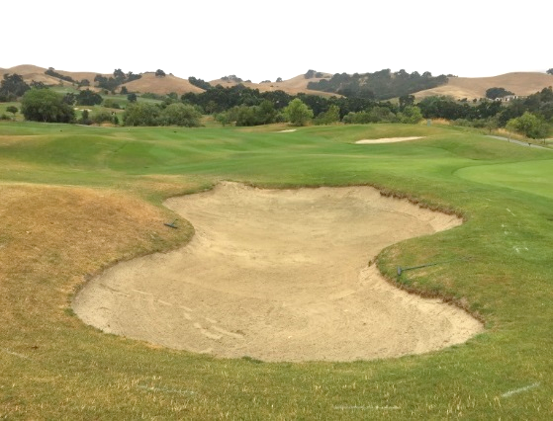

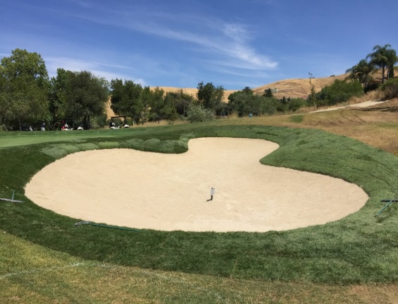
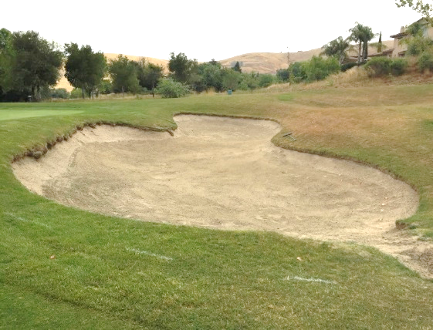

City Medians
- Replaced 45 irrigation heads on North Valley trails median in preparation of a new plant installation
- Installed new plantings in partnership with Ponderosa Homes at North Valley Trails street
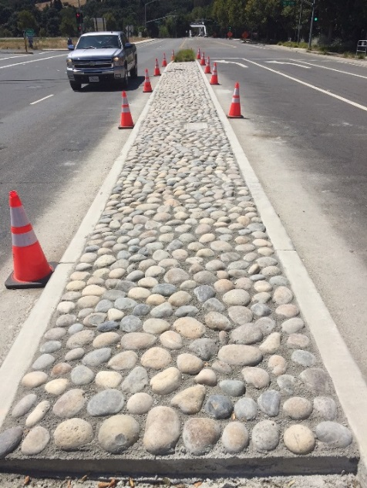
- Installed new cobblestone at the 680/Bernal underpass

Downtown Main Street
- Installed three new trees

Urban Forest Management
- Removed a Purple Robe Locust on Main street in front of Norm’s Barber Shop.
- Removed a large Modesto Ash tree located at 337 Main Street in front of Bank of America.
- Removed a large pear treat at 157 West Angela Street due to a major branch failure

ALTERNATIVE ACTION

Any other action as determined by the Commission.

Submitted by:

B. Stewart
Brandon Stewart
Park Superintendent

