 | Planning Commission  Staff Report
 | January 13, 2016
 | Item 5.a.

SUBJECT: P15-0741

APPLICANT/
PROPERTY
OWNER: Vijay Kumar

PURPOSE: Application for Design Review approval to construct an approximately 4,225-square-foot single-story home with an attached approximately 623-square-foot garage.

GENERAL PLAN: Low Density Residential (<2.0 du/ac)

ZONING: PUD-LDR/C/PHS/WO (Planned Unit Development – Low Density Residential/Commercial/Public Health and Safety/Wildlands Overlay

OVERLAY
DISTRICT: West Foothill Road Corridor Overlay District.

LOCATION: 5967 Kolb Ranch Drive (Lot 12 of the Kolb Ranch Estates)

EXHIBITS: A. Draft Conditions of Approval
B. Proposed Plans and Visual Analysis dated “Received, December 29, 2015” and Green Building Checklist
C. Arborist Report dated “Received, December 08, 2015”
D. Pleasanton Municipal Code Section 18.78: West Foothill Road Corridor Overlay District and West Foothill Road Corridor Design Guidelines
E. Kolb Ranch Estates Design Guidelines
F. PUD-99-03, Ordinance No. 1805
G. Location and Noticing Map

BACKGROUND

The project site is part of the Kolb Ranch Estates development. The Kolb Ranch development is located within the West Foothill Road Corridor Overlay District (WFRCOD). The WFRCOD is an overlay district with regulations intended to implement the goals and policies of the General Plan as they relate to maintaining the rural character of the Foothill Road corridor. Planned Unit Development (PUD) prezoning and development plan approvals were granted for 12 single-family lots, a public park, open space, and designation of an approximately 5.22-acre area for a future senior care facility on May 16, 2000 (PUD-99-03). Since custom homes were proposed, Design Standards were established to guide future development of the lots. Lots 1-10 were approved with Design Standards based on the City’s R-1-20,000 zoning district and Lots 11-12 were approved with Design Standards based on the City’s R-1-40,000 zoning district. The Design Standards were modified in 2002 to reflect changes in grading and lot configuration. PUD conditions of approval required all new homes in the development to be reviewed and approved by the Planning Commission.

In 2005, Design Review approval to construct semi-custom homes on Lots 1-10 (PDR-446) of the Kolb Ranch Estates was granted. Lots 11-12 remained custom lots governed by the original Design Standards. All 12 lots are shown below in Figure 1. Accordingly, the application for Design Review for the custom home at 5967 Kolb Ranch Drive (Lot 12) is before the Planning Commission for consideration.

Figure 1: Site Aerial Photograph

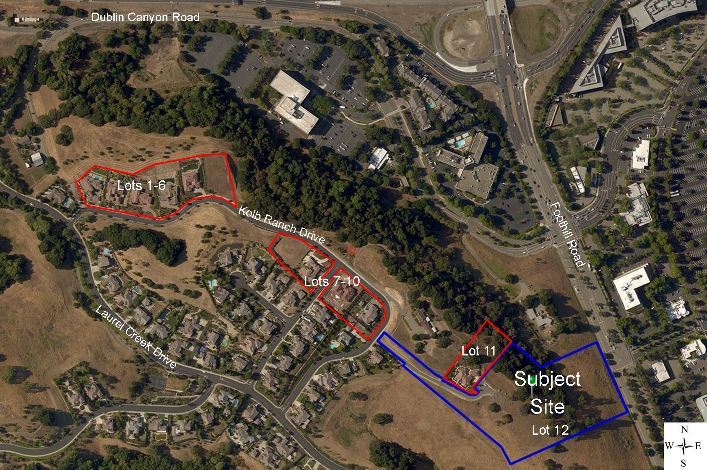

SITE DESCRIPTION
N

The project site is located on a flag lot accessed via a long private shared driveway, and is immediately surrounded by open space to the south and southwest and residential homes to the northwest and northeast. The home would be located on top of a hill with the area surrounding the home steeply sloping down from an elevation of approximately 555 feet to the east towards Foothill Road, at an elevation of approximately 383 feet. The hillside contains native oak woodlands and grassland vegetation. The site’s surroundings include Dublin Canyon Road to the north, Foothill Road to the east, and open space associated with The Preserve development to the west and south.

The lots within the Kolb Ranch Estates Development range in size from 26,000 square feet to 34,000 square feet, except for the subject lot which is approximately 8.17 acres in area. The subject property is currently vacant with no site improvements except for the shared driveway with 5973 Kolb Ranch Road shown in Figure 2.

Figure 2: Project Site

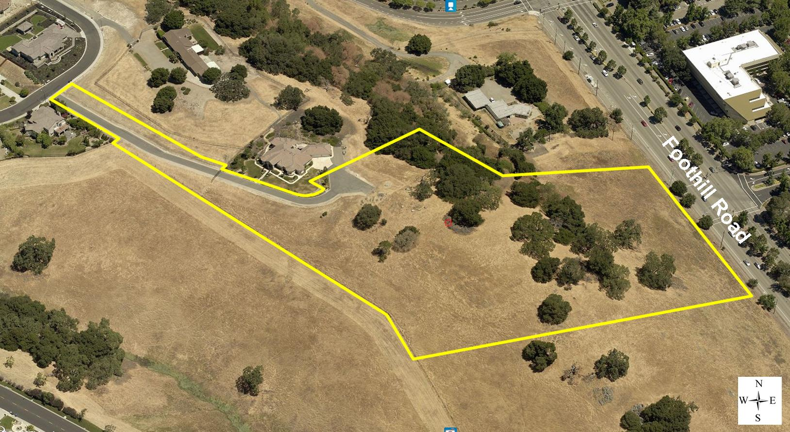

PROJECT DESCRIPTION

The applicant, Vijay Kumar, is requesting approval of a custom home with related improvements on Lot 12 (5967 Kolb Ranch Drive). The applicant’s proposal, as conditioned, complies with the Design Standards and conditions of approval for PUD-99-03, as well as the WFRCOD (Exhibit D and E) for this site and includes the following:

- An approximately 4,225-square-foot, single story, custom home with a 623-square-foot attached three-car garage. The proposed house includes four bedrooms, a bonus room, media room, and great room.
- The proposed building height is 24 feet.
- Required green building measures, such as permeable pavers, energy star appliances, and preparation for photovoltaic installation.
- Installation of a variety of landscaping plants and trees, and removal of one tree.
- Minor grading and installation of garden retaining walls within the rear yard for tree protection.
- A proposed building design with a contemporary architectural style.
- A house exterior that includes cream colored stucco and stone material.

ANALYSIS

The proposed house design provides attractive articulation and ample use of stone treatments and detailing. The height and massing of the house will be consistent with the neighborhood and therefore the house will not create any adverse visual impacts on the neighborhood.

Visual Analysis
A visual analysis was prepared in conjunction with the review of PUD-99-03. During the review of the visual analysis, staff concluded that Lots 7, 8, and 12 were the only lots in Kolb Ranch Estates that may be visible from areas to the east of Foothill Road. In order to ensure that the proposed project would not adversely impact views, the applicant has provided a focused view analysis shown in Figure 3, to include the proposed home design, including the proposed pad level. The submitted view analysis shows that the proposed home will be visible in areas above the tree canopy as well as potentially through the canopies. Staff has reviewed the analysis and project with respect to building height, pad elevation, location, and proposed new landscaping and believes that while the home will be visible, the proposed landscaping and building materials as conditioned will help the home blend into the hillside.

Figure 3: View Analysis

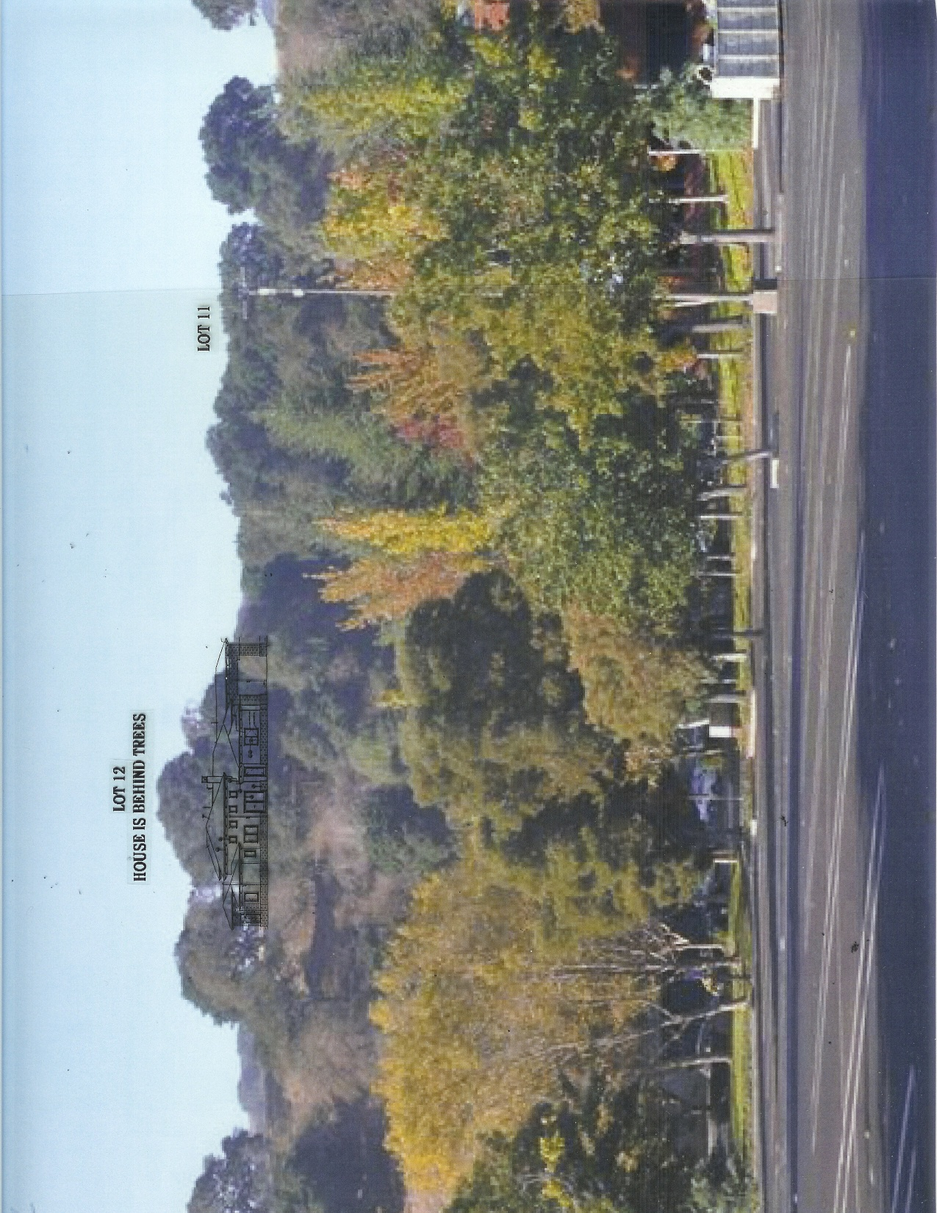

Site Design
The Design Standards that were established by PUD-99-03 were based on the R-1-40,000 zoning district and address setbacks, building height, materials and colors, grading, house size, accessory structure location, fencing, landscaping, etc. Table 1 and Figure 4 below, demonstrate the proposed project’s conformance to the development standards specified within the Design Guidelines.

Table 1: Development Standards
 | Development Standards | Proposed Project
Front Yard Setback | 30 feet minimum | 114 feet
Side Yard Setbacks | 5 feet minimum/50 feet combined | over 100 feet/over 200 feet combined
Rear Yard Setback | 30 feet minimum | over 100 feet
Building Height* | 24 feet, as measured from the lowest to the highest points on the house | 24 feet
Floor Area Ratio  (FAR) | 25% or 4,500 square feet, whichever is less** | 1.2% or 4,248 square feet
* PUD-99-03-2M allowed for a maximum height of 24 feet
** Garage area over 600-square-feet is included within FAR

Figure 4: Site Plan

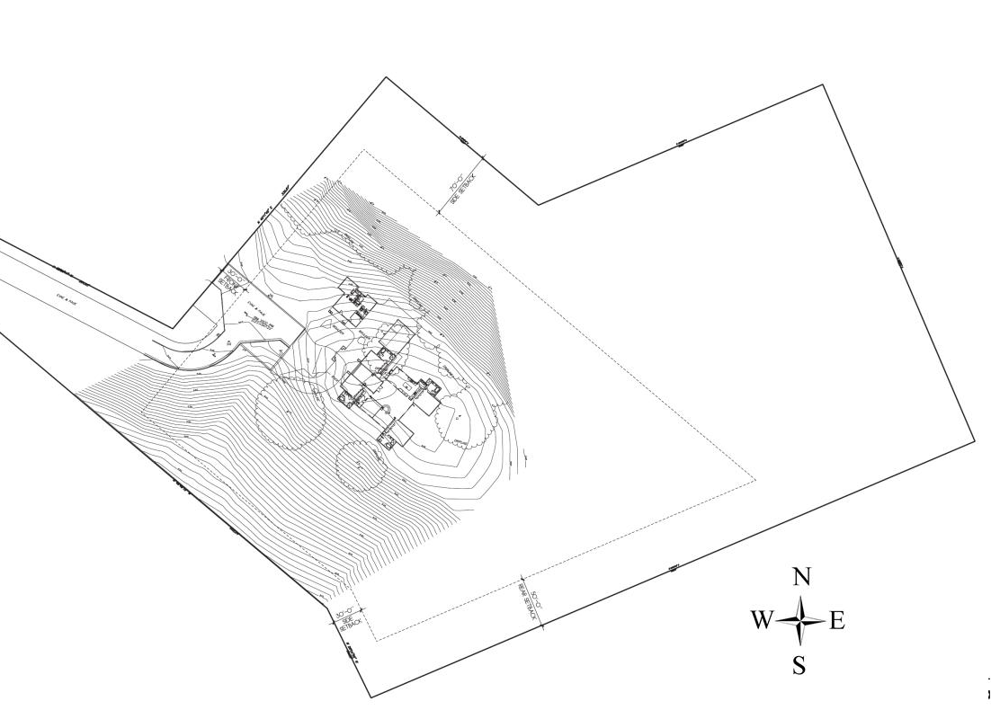
Building Design

The proposed house is a single story home with articulated wall lines that reduce the perceived massing of the home and promote visual interest. The roof lines are varied to mitigate the massing of the structure and the majority of the front façade is treated with wainscot and entry veneer to soften the visual presence of the home.

The Design Standards state that where lot sizes and configuration permit, garages are encouraged to be designed in such a manner that the garage doors do not face the street and/or are not the primary element of the building elevation. Although the home has been designed with the 3-car garage along the front elevation of the home as shown in Figure 5, the home is setback from the street down the private drive and will not be highly visible. Staff believes that the design and location reduce the visual impact of the three-car garage, and are thus consistent with the Design Standards.

Figure 5: Front Elevation

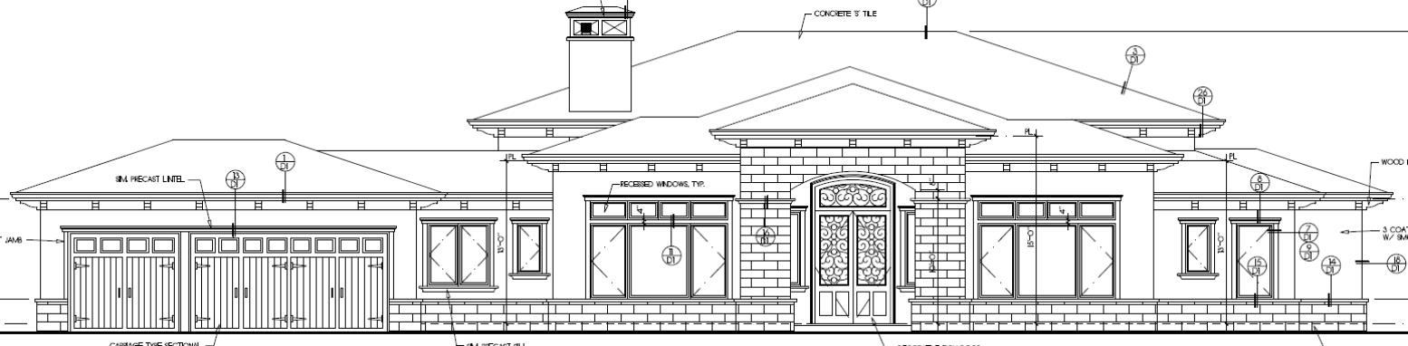

The materials and colors for this development are governed by the PUD conditions of approval, the approved Design Standards, and the WFRCOD. The PUD conditions of approval and the Design Standards incorporate similar material and color guidelines as found in the WFRCOD. The Design Standards state that natural materials such as wood siding and stone should be used on the homes; however, stucco siding may be allowed when used in conjunction with another building material, subject to design review approval. The PUD conditions of approval further state that “at least 50 percent of the exterior main structure building wall surfaces shall be either natural wood, stone and/or brick, and the remainder of the exterior building wall material may be stucco.”

The proposed house includes a mixture of stucco and stone materials. Although the plans identify the stone as Coolstone, the applicant has proposed an El Dorado "Coastal Reef" stone that staff feels is more appropriate to be used as wainscot around the entire home as well as the porte cochere of the front elevation and is also used as an accent on the side and rear elevations to articulate walls on the home. Each elevation features a wall which will be covered in stone to accentuate a particular area of interest, such as the front entry. The revised Coastal Reef stone provides a natural material that is more compatible with the Design Guidelines and surrounding neighborhood. The Design Standards also require that at least 50 percent of the structure be covered with a natural material. The applicant has included stone accents on all elevations, although it is unclear whether the proposed design meets the 50 percent requirement. Staff has included a condition of approval that prior to issuance of building permits the applicant provide detailed calculations for all exterior elevations, confirming that a minimum of 50 percent of the elevations are stone. The final materials and colors will need to be resubmitted to the Community Development Director for review and approval to verify they are consistent with the PUD conditions of approval, the Design Standards of the development, and applicable provisions in the WFRCOD.

Landscaping

The applicant has provided a Landscaping Plan that largely maintains the existing oak trees on-site and adds a variety of trees to the hillside. The applicant is proposing to remove one heritage tree on-site. The tree proposed for removal is a declining tree in poor health with extensive decay in the trunk and branches. Most of the tree has died and several stems have failed. To mitigate the tree removal and screen the home from view, the applicant is proposing to add 34 new trees, including nine 24-inch box Coast Live Oak trees and one 36-inch box Valley Oak tree. The majority of the trees planted will be located to the northwest between the existing neighbor and the proposed home and to the northeast facing Interstate 680 and Stoneridge Mall. There are currently few trees along the south side of the proposed home. Staff has included a condition of approval to require a minimum of five additional native oak trees to be planted to the south and southeast of the home, which would be reviewed and approved by the City Landscape Architect. The proposed Landscape Plan as conditioned will provide adequate landscaping for the site as required by the Design Standards. The combination of plant materials and hardscape promote visual interest on the site and will also provide adequate screening of the site from adjacent properties.

West Foothill Road Corridor Overlay District

As mentioned previously, PUD 99-03 contained a view analysis of the proposed project. The analysis showed that only the upper portions of the houses located on Lots 7, 8, and 12 may be visible from the I-580/Foothill Road overpass. The revised analysis shows that the proposed home will be slightly visible beyond the tree canopy; however, the proposed home as designed with revised pad grading and additional landscape screening would not adversely affect the view from the surrounding area.

Staff believes that the proposed project, as conditioned, conforms to the applicable WFRCOD regulations including those pertaining to house size, Foothill Road setback, landscaping, retaining walls, and building design. Overall, staff finds that the project has been designed and conditioned to conform to all applicable requirements of the WFRCOD.

Green Building Measures

The attached Green Building checklist shows that the proposed project would achieve 50 points, consistent with the City’s ordinance. As conditioned, the final Green Building measures and score will be determined with the review of the building permit application. The project will also need to conform to the State of California’s Green Building Standards Code, “CALGreen.”

PUBLIC NOTICE

All property owners within 1,000 feet of the subject site were notified of the proposed project. A map showing the noticing area can be found in Exhibit G. At the time this report was prepared, staff had not received any comments or concerns about the project.

CONCLUSION

Staff believes that the proposed home is designed in a manner that is consistent with applicable policies, regulations, and guidelines, including those required by the WFRCOD. Staff believes the proposed project should receive a favorable determination by the Planning Commission in that the proposed design is attractive and would be compatible with the homes in the surrounding developments.

ENVIRONMENTAL ASSESSMENT

An Initial Environmental Study and a Negative Declaration for PUD-99-03 were adopted by the City Council on May 2, 2000 in conformance with California Environmental Quality Act (CEQA). No supplemental environmental review is necessary because there are no substantial changes to the project previously analyzed. Furthermore, there is no new information of substantial importance which was not known at the time the Negative Declaration was adopted regarding the project or its effects, mitigation measures, or alternatives. Any previously identified effects or impacts are mitigated to a level of insignificance, with the mitigation measures incorporated into the project’s design or imposed pursuant to the conditions of approval.

STAFF RECOMMENDATION

Staff recommends that the Planning Commission approve P15-0741 subject to the conditions listed in Exhibit A.

Primary Author:
Jennifer Hagen, Associate Planner, 925-931-5607 or jhagen@cityofpleasantonca.gov

Reviewed/Approved By:
Steve Otto, Senior Planner
Adam Weinstein, Planning Manager
Gerry Beaudin, Community Development Director

