 | Planning Commission  Staff Report
 | July 11, 2012
 | Item 5.a.

SUBJECT: P11-0053

APPLICANT: U-Haul Pleasanton

PROPERTY OWNERS: Earl and Barbara Adams

PURPOSE: Application for Conditional Use Permit to operate an automobile rental business at 3657 Old Santa Rita Road, Suite B.

GENERAL PLAN: Retail/Highway/Service Commercial/Business and Professional Offices

ZONING: Service-Commercial (C-S) District

LOCATION: 3657 Old Santa Rita Road, Suite B

EXHIBITS: A. Draft Conditions of Approval
B. Project Plan and Applicant Narrative
C. Letter from Zone 7 Water Agency, dated April 23, 2012
D. Location Map
E. Noticing Map

BACKGROUND
The applicant proposes a conditional use permit to allow for the rental of U-Haul vehicles at the subject location. The site is zoned Service-Commercial (C-S) and automobile rental is conditionally permitted in the C-S zoning. The applicant had commenced operation of the vehicle rental business prior to securing the conditional use permit and thus had been advised by Code Enforcement to submit for and pursue a conditional use permit.
SITE DESCRIPTION
The subject property is located on the west side of Old Santa Rita Road. The site is bounded by Eaves Pleasanton Apartments to the south, automobile repair and service uses to the north, a self-storage facility and storage yards across Old Santa Rita Road to the east, and Tassajara Creek and the Carr America site to the west. Figure 1 provides an aerial map of subject site and surrounding properties.

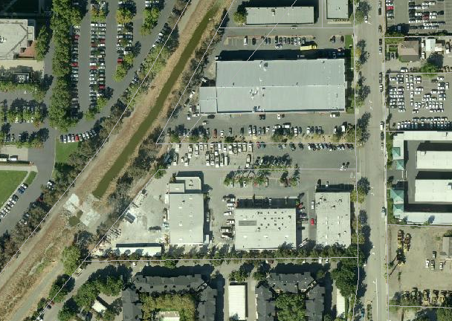
Parking Area
Old Santa Rita Road
Subject Building
Tassajara Creek
N
Carr America
Eaves Pleasanton Apartments
Self-Storage Facility
Automobile servicing businesses
Figure 1: Aerial Map of Subject Site and Surrounding Properties

Figures 2 and 3 on the following page show photographs of the subject building and of the parking area for the rental vehicles.

The subject site and many of the surrounding sites have blanket conditional use permits that allow for warehousing, wholesale businesses, contractor’s operations, automobile repair, paint and upholstery, auto body shops, cabinet shops, and outdoor storage.

Other businesses within the same building include a restaurant and a car stereo installation, repair and detailing shop. A swimming pool contractor and plumbing service business are located in the building behind the subject building. A self-storage facility is located across Old Santa Rita Road and several businesses that specialize in automobile detailing services are housed in the building to the north of the parking area. Avis-Rent-A-Car obtained conditional use permit approval from the Planning Commission in 1997 and is located further north on Old Santa Rita Road.

Zone 7 Water Agency owns the portion of the parking lot directly to the north of the subject property. The owner of the subject property has secured an agreement with the Zone 7 Water Agency to utilize the parking area of this lot. A license agreement between the property owner of the subject property and Zone 7 Water Agency allows for the use of the space labeled as “parking area” in Figure 1. The license agreement is discussed further in the “Project Description” section of this staff report.

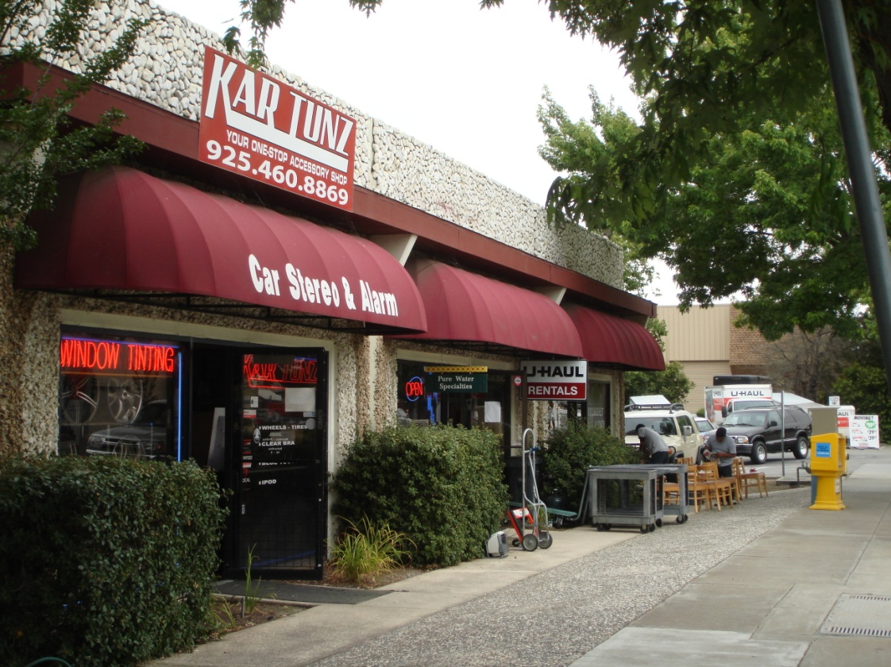
Figure 2: Photograph of front of building

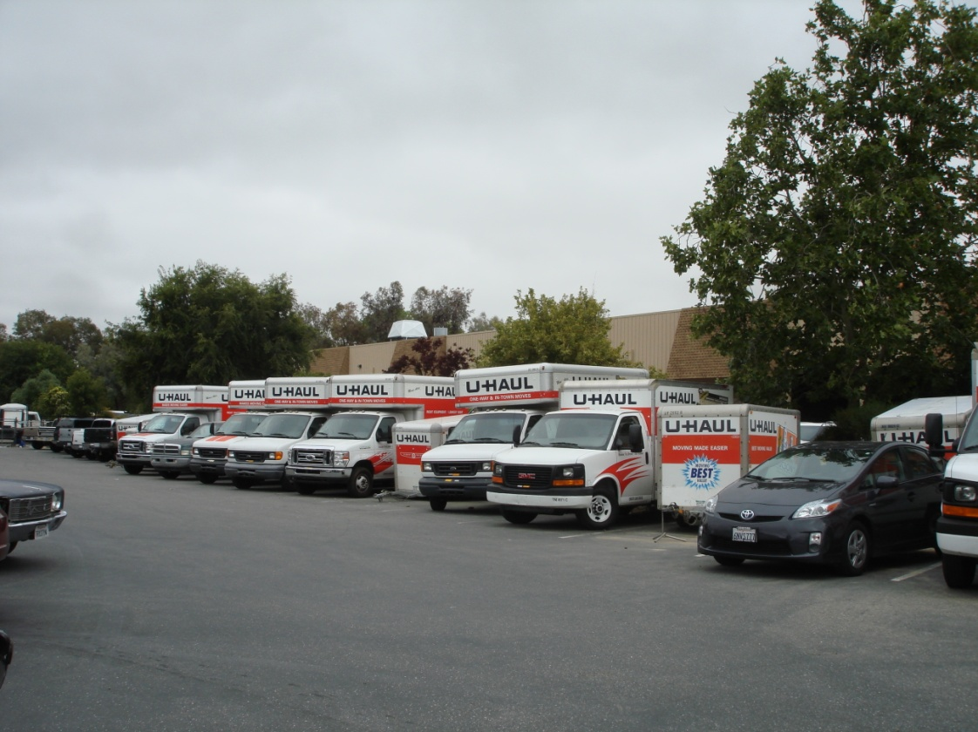
Figure 3: Photograph showing parking area

PROJECT DESCRIPTION
The applicant proposes to rent U-Haul trucks, trailers, and vans from the subject location. The operation of the business is described in the project narrative, attached to this report as Exhibit B. The administration of the business, including reservations and paper-work related to vehicle rentals, is run from the office located within the building at 3657 Old Santa Rita Road. The applicant also runs another business from the subject tenant space, Pure Water Plumbing Specialties, which provides water refilling services and warehouses plumbing supplies. The vehicles and trailers ready to be rented are parked on the property located directly to the north that is owned by Zone 7 Water Agency. The applicant’s lease with the property owner allows parking up to 15 U-Haul vehicles and trailers on the Zone 7 Water Agency property, although the applicant anticipates increasing this number to 24 vehicles and trailers in the future. Therefore, this Conditional Use Permit is for up to 24 vehicles and/or trailers.

The types of vehicles available for rental vary in size from a 5-foot by 9-foot trailer to a 26-foot long truck, although the applicant has indicated that most trucks parked at the site are 10-feet, 14-feet, or 17-feet long, and the longer trucks are only reserved occasionally. Since trucks may be rented from the subject location and driven to another destination, or a customer may drop off a rental vehicle at the subject location, the inventory may change from day to day.

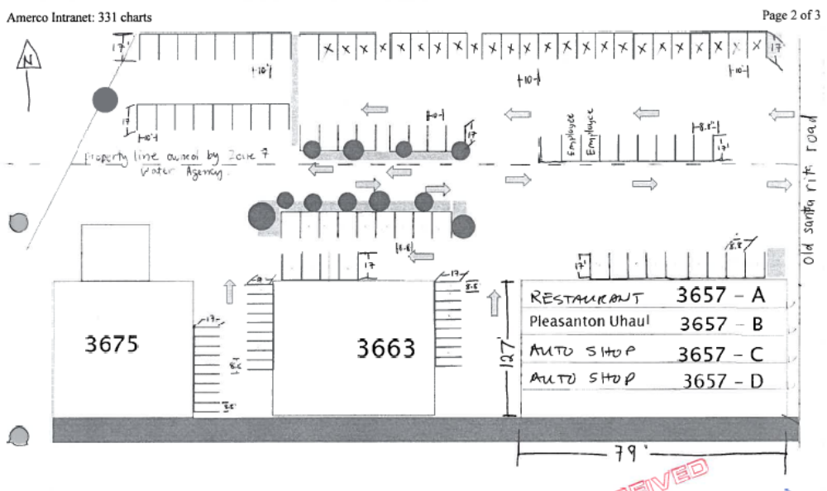
Old Santa Rita Road
Zone 7 Property
N
Figure 4: Site Plan
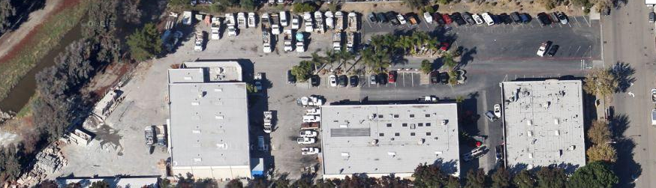
Old Santa Rita Road
Google Maps

Figure 5: Aerial Photograph

The business is open from 8:00 a.m. to 7:00 p.m., Monday – Saturday (although occasionally the business will close at 6:00 p.m.), and from 8:00 a.m. to 12:00 p.m. on Sundays, and has three part-time employees. The subject suite, Suite B, is approximately 800 square feet and as shown in Figure 4, is located at 3657 Old Santa Rita Road, the building closest to the street.

As shown in Figure 5, the parking spaces are angled, not 90-degrees as shown in the applicant’s site plan. The parking spaces outlined in solid yellow in both Figures 4 and 5 represent the 15 parking spaces currently used for U-Haul vehicles or trailers. The parking outlined in dotted yellow represent the additional 9 parking spaces the applicant would like to use for a total of 24 spaces.

License Agreement
The property owner has a license agreement with Zone 7 Water Agency that allows him access and use of the property owned by Zone 7. One of the stipulations of the agreement is that the owner is not allowed to sublease the Zone 7 property without written approval from Zone 7. Since the business operator of the U-Haul business would be a sub-licensee of the Zone 7 property, staff asked the applicant to obtain authorization from Zone 7 Water Agency allowing the property owner to sublease the property to the U-Haul business operator. The applicant has obtained this authorization and is attached to this staff report as Exhibit C. A condition stipulates that should the license agreement with Zone 7 Water Agency expire, be terminated, or revoked, the subject conditional use permit would immediately expire.
ANALYSIS
Conditional uses are uses that, by their nature, require individual review to ensure that impacts associated with their use will be minimal. Conditional use permits may be subject to appropriate conditions to ensure that any potential adverse impacts associated with the use will be mitigated.

Land Use
One of the purposes in reviewing a conditional use permit application is to analyze the effect of the proposed use on surrounding land uses. Many of the other businesses surrounding and in vicinity of the subject site include automotive repair, self-storage facility, and warehousing. Automobile sales businesses and an automobile rental business are located further to the north of the subject site on Old Santa Road and Rosewood Drive. Thus the proposed business and its operation are compatible with the existing businesses on the site and in vicinity of the subject property.

Site Circulation and Parking
The on-site parking (excluding parking on the Zone 7 property) is shared by all three buildings on the subject site. The applicant’s narrative indicates that U-Haul Pleasanton has three part-time employees who work in shifts. One employee works from 8:00 a.m. to 1:00 p.m. daily, another works from 1:00 p.m. to 4:00 p.m. daily, and the third employee works from 4:00 p.m. to 6:00 p.m. Monday through Friday. Therefore, there is only one employee present at any one time.

The subject site has 49 parking spaces and an additional 58 parking spaces are located on the Zone 7 Water Agency property directly to the north. Based on Alameda County records, the total square footage of buildings on the subject property is 25,998 square feet, resulting in a parking ratio of one space for each 530 square feet. Since the subject tenant suite is approximately 800 square feet, 2 spaces are “theoretically” allocated to the subject tenant space. Since the 58 parking spaces on the Zone 7 property are on a separate property than the subject property, they were not required parking spaces for the buildings on the subject site. As discussed previously in this report, approval of the use of these parking spaces is granted by Zone 7 Water Agency in the form a license agreement with the property owner of the subject property, Mr. Tony Adams.

Pleasanton Municipal Code section 18.88.030(C) requires that commercial service enterprises which handle only bulky merchandise such as motor vehicles require one space for each 500 square feet of gross floor area, except for floor area used exclusively for storage or truck loading. Administrative offices require 1 parking space for each 300 square feet of gross floor area.

If the standards for commercial service enterprises which handle only bulky merchandise were to be applied to the business, then 2 parking spaces would be required. If the standards for office were to be applied to the business, then 3 parking spaces would be required for the use. These parking requirements do not take into account any parking spaces used for vehicle storage. As noted previously, vehicle storage is on a separate parcel and would not adversely impact on-site parking for other tenants.

Typically, a person wishing to rent a vehicle will be accompanied by another person who will drive him/her to the site and the renter will drive the rental vehicle to the final destination. Since the person dropping off the renter and the renter are not expected to stay in the office for an extended period of time (to complete any paperwork related to reservations and/or terms of the rental agreement), the on-site parking spaces needed for customers will be limited. Additionally, only one employee is at the site at a given time. Therefore, staff finds that the off-street parking to be adequate for the proposed use. A condition requires that all vehicles waiting to be rented be parked on the Zone 7 property and not on the public street. Another condition requires U-Haul vehicles to be legally parked in marked parking spaces and prohibits them from blocking drive aisles.

Noise
Since the proposed use of the tenant space consists of office activities, the operation of the business is not expected to generate noise audible beyond the boundaries of the suite. The driving and parking of rental vehicles and trailers to and from the site would be no louder than the noise generated by surrounding businesses, or by vehicles traveling to and from surrounding businesses. A condition of approval requires that the no servicing, cleaning, washing, or maintenance shall occur on the site. The closest residential uses are the Eaves Pleasanton Apartments to the south of the site. However, since many of the surrounding businesses are commercial in nature and the subject use does not have any operations that would create or cause loud noise, the potential impact to residences regarding noise is expected to be minimal.

PUBLIC NOTICE
Notices regarding the proposed Conditional Use Permit application and related public hearing were mailed to the surrounding property owners and tenants within a 1,000-foot radius of the project site. A map showing the noticing area is attached to this report. The public notice was also published in The Valley Times. At the time this report was prepared, staff has not received any comments or concerns.
GENERAL PLAN CONSISTENCY
The Land Use Element of the General Plan states several programs that support the proposed project.

Program 8.2: Use the City’s development review procedures to minimize intrusions into existing neighborhoods.

Program 15.2: Promote the location of business services in Pleasanton to support industrial, commercial, and office complexes.

Staff finds that the proposed business meets Program 15.2 in that it will provide a service to residents and the general public. The zoning code conditionally permits a use such as the proposed automobile rental business when its operation will not be detrimental to the surrounding properties. Additionally, the proposed operation of the business will be consistent with Program 8.2 in that conditions of approval will ensure that the business will be a harmonious and non-intrusive use compatible with the adjacent neighbors.
FINDINGS
The Planning Commission must make the following findings prior to granting the use permit:

- That the proposed location of the conditional use is in accordance with the objectives of the zoning ordinances and the purpose of the district in which the site is located.

The objectives of the Zoning Ordinance include fostering a harmonious, convenient, workable relationship among land uses, protecting land uses from inharmonious influences and harmful intrusions, promoting a safe, effective traffic circulation system, and ensuring that public and private lands ultimately are used for the purposes which are most appropriate and beneficial to the City as a whole. One of the purposes of the C-S zoning district is to provide sites for businesses that typically are not found in shopping centers, that usually have relatively large sites providing off-street parking, and that attract little or no pedestrian traffic.

Staff believes the proposed use as conditioned would be consistent with the zoning ordinance objectives in that it would provide residents and the general public with a location to rent vehicles needed for moving or other needs. The site is located in the vicinity of other automobile-related and service uses, and is located on a site where parking is allocated to the vehicles and trailers to be rented. As conditioned, the operation of the business is expected to be compatible with other businesses located on the same site and in the vicinity. Staff believes that this finding may be made.
- That the proposed location of the conditional use and the conditions under which it would be operated or maintained will not be detrimental to the public health, safety, or welfare, or materially injurious to the properties or improvements in the vicinity.

Conditions of approval require the operation of the business not interfere or result in negative impacts to surrounding businesses and land uses. The operation of the business consists of an office with on-site parking of vehicles, which is not expected to result in noise impacts to neighboring sites. No servicing, washing, or maintenance of U-Haul vehicles would occur on the site. Further, the conditions of approval require the applicant to mitigate potential nuisances that may arise with the proposed use. Staff believes that this finding may be made.

- That the proposed conditional use will comply with each of the applicable provisions of the Municipal Code which apply to Conditional Uses.

Conditional uses require special consideration so that they may be located properly with respect to the objectives of zoning ordinance. In order to uphold these objectives, the Planning Commission is empowered to grant and to deny applications for use permits for such conditional uses and to impose reasonable conditions upon the granting of use permits. Granting a conditional use permit to the applicant for the subject use would be consistent with the City’s ability to regulate zoning as listed in the Pleasanton Municipal Code. Conditions of approval require that the business operate with minimal impact to surrounding businesses and land uses. Should the operation of the business result in negative impacts, the use permit can be modified or revoked. Therefore, staff believes that this finding may be made.
ENVIRONMENTAL ASSESSMENT
This project is categorically exempt from environmental review pursuant to California Environmental Quality Act Guidelines, Section 15301, Existing Facilities, Class 1. Therefore, no environmental document accompanies this report.
CONCLUSION
The conditional use permit will allow U-Haul Pleasanton to maintain its operation at the subject site. Conditions of approval have been recommended which will ensure that the safety and general welfare of the surrounding area is maintained. The proposed use, as conditioned, will be compatible with the surrounding uses and properties and will not result in an impact to nearby businesses.

STAFF RECOMMENDATION
Staff recommends that the Planning Commission approve Case P11-0053 by taking the following actions:
- Make the required conditional use permit findings as listed in the staff report; and
- Approve Case P11-0053 subject to the conditions listed in “Exhibit A.”

Staff Planner: Shweta Bonn / (925) 931-5611 / sbonn@ci.pleasanton.ca.us

